<https://youtu.be/nl58nIVaX88>

Imp : Ant project structure

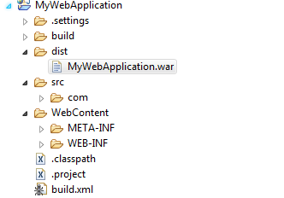

Way of running ant build

**Run the ant build**

To run the build, you have two options –

1. Run from comamnd prompt. The comamnd to run is :

$ ant -f build.xml

1. Run from eclipse. Choose this menu option.

Right click on build.xml -> Run as -> Ant build

**Best Example for More configartion of ant build:**

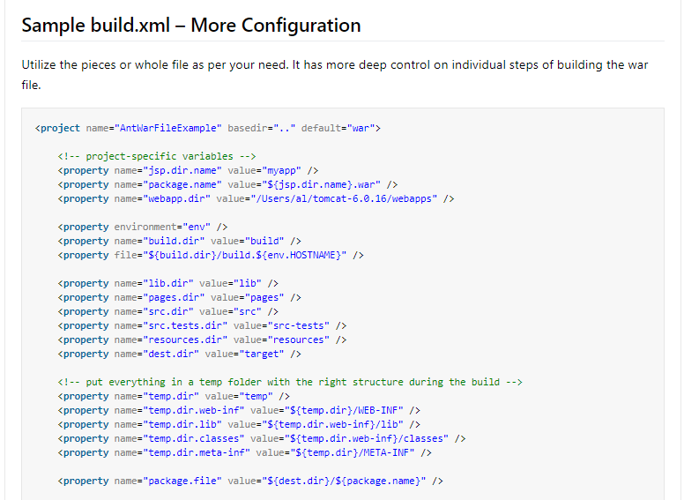

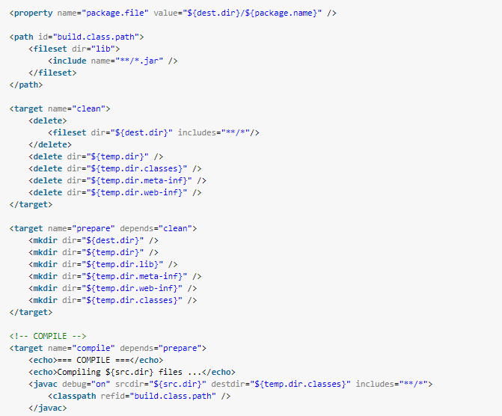

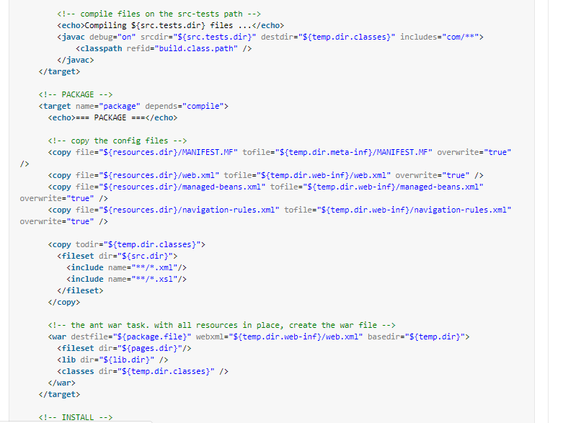

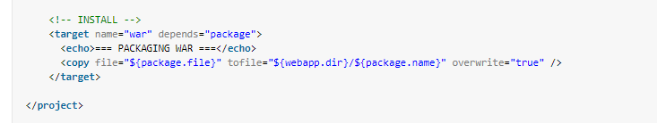

**My project :**

<?xml version="1.0" encoding="UTF-8"?>

<!DOCTYPE project>

<project name="IdentityService" default="devBuild" basedir="." xmlns:ivy="antlib:org.apache.ivy.ant">

<!-- Properties -->

<property name="version" value="1.0" />

<property name="sourceDir" value="../src" />

<property name="unitTestSourceDir" value="../UnitTests" />

<property name="librariesDir" value="../lib" />

<property name="testLibraries" value="../testlib"/>

<property name="configFilesDir" value="../resources" />

<property name="binariesDir" value="../build" />

<property name="distDirName" value="distribution" />

<property name="standaloneDir" value="../standalone"/>

<property name="testBinariesDir" value="../tests" />

<property name="unitTestReports" value="../junitreports" />

<property name="executionDirName" value="proview"/>

<!-- The following are expected to be passed in, these are here just for developer builds -->

<property name="WORKSPACE" value="" />

<property name="ARTIFACT_NAME" value="IdentityService-20170126-0.zip"/>

<path id="compile.classpath">

<fileset dir="${librariesDir}">

<include name="*.jar" />

</fileset>

<fileset dir="${testLibraries}">

<include name="*.jar" />

</fileset>

</path>

<!-- Targets -->

<target name="clean">

<delete dir="${binariesDir}" />

<delete dir="${standaloneDir}" />

<delete dir="${testBinariesDir}" />

<delete dir="${unitTestReports}" />

</target>

<target name="init">

<mkdir dir="${binariesDir}" />

<mkdir dir="${standaloneDir}" />

<mkdir dir="${testBinariesDir}" />

<mkdir dir="${unitTestReports}" />

</target>

<target name="ivypull">

<!-- Resolve dependencies with Ivy -->

<taskdef resource="org/apache/ivy/ant/antlib.xml" uri="antlib:org.apache.ivy.ant">

<classpath>

<fileset dir="ivy" includes="ivy-*.jar" />

</classpath>

</taskdef>

<ivy:settings file="ivysettings.xml" />

<ivy:retrieve file="ivy.xml" conf="build" pattern="${librariesDir}/[artifact]-[revision].[ext]" sync="true" taskname="ivy" />

<ivy:retrieve file="ivy.xml" conf="unittest" pattern="${testLibraries}/[artifact]-[revision].[ext]" sync="true" taskname="ivy" />

</target>

<target name="compile" depends="init">

<javac destdir="${binariesDir}" debug="on" debuglevel="lines,source" includeantruntime="false" srcdir="${sourceDir}">

<classpath refid="compile.classpath" />

</javac>

</target>

<target name="unitTestCompile" depends="init">

<javac destdir="${testBinariesDir}" srcdir="${unitTestSourceDir}" includeantruntime="false" debug="on">

<classpath>

<pathelement path="${binariesDir}" />

<path refid="compile.classpath" />

</classpath>

</javac>

</target>

<target name="unitTestReport" depends="-runUnitTestsInt">

<junitreport todir="${unitTestReports}">

<fileset dir="${unitTestReports}">

<include name="TEST-*.xml" />

</fileset>

<report todir="${unitTestReports}" />

</junitreport>

<fail if="junit.failed" message="Unit test(s) failed. See reports." />

</target>

<target name="unitTestRun" depends="-runUnitTestsInt">

<fail if="junit.failed" message="Unit test(s) failed. See reports." />

</target>

<target name="-runUnitTestsInt" depends="unitTestCompile">

<junit printsummary="true" failureproperty="junit.failed" forkmode="once">

<classpath>

<pathelement path="${testBinariesDir}" />

<pathelement path="${binariesDir}" />

<pathelement path="${unitTestSourceDir}" />

<pathelement path="${configFilesDir}" />

<path refid="compile.classpath" />

</classpath>

<formatter type="xml" />

<batchtest fork="yes" todir="${unitTestReports}">

<fileset dir="${testBinariesDir}" excludes="**/TestHtmlConversion.class,**/process/*">

<include name="**/Test*.class" />

</fileset>

</batchtest>

</junit>

</target>

<target name="createJar">

<jar destfile="${binariesDir}/${ant.project.name}.jar" basedir="${binariesDir}" includes="**/*.class">

</jar>

</target>

<target name="createZip" depends="-preZip">

<zip destfile="../${ARTIFACT_NAME}" baseDir="${standaloneDir}">

</zip>

</target>

<target name="-preZip">

<!-- clean up an existing standalone directory, if it exists -->

<delete file="../${ARTIFACT_NAME}.zip"/>

<delete dir="${standaloneDir}/${distDirName}" failonerror="off" includeemptydirs="on" />

<mkdir dir="${standaloneDir}/${distDirName}" />

<copy todir="${standaloneDir}/${distDirName}/${executionDirName}">

<fileset dir="${binariesDir}/">

<include name="*.jar" />

</fileset>

</copy>

<copy todir="${standaloneDir}/${distDirName}/lib">

<fileset dir="${librariesDir}">

<include name="**/*.jar" />

</fileset>

</copy>

<copy todir="${standaloneDir}/${distDirName}/resources">

<fileset dir="${configFilesDir}"/>

</copy>

<copy todir="${standaloneDir}/${distDirName}/bin">

<fileset dir="../bin"/>

</copy>

<copy todir="${standaloneDir}" file="../DockerIdentity"/>

</target>

<target name="updateAWSDB">

<replaceregexp file="${configFilesDir}/identityService.properties"

match="jdbc\:postgresql.*"

replace="jdbc:postgresql://proview-ci-systemdb.cjuyahw1e5vf.us-east-1.rds.amazonaws.com:5432/systemdb"

byline="true"

/>

</target>

<target name="devBuild" depends="clean, ivypull, compile, updateAWSDB, unitTestReport" description="For use on developer machines">

</target>

</project>



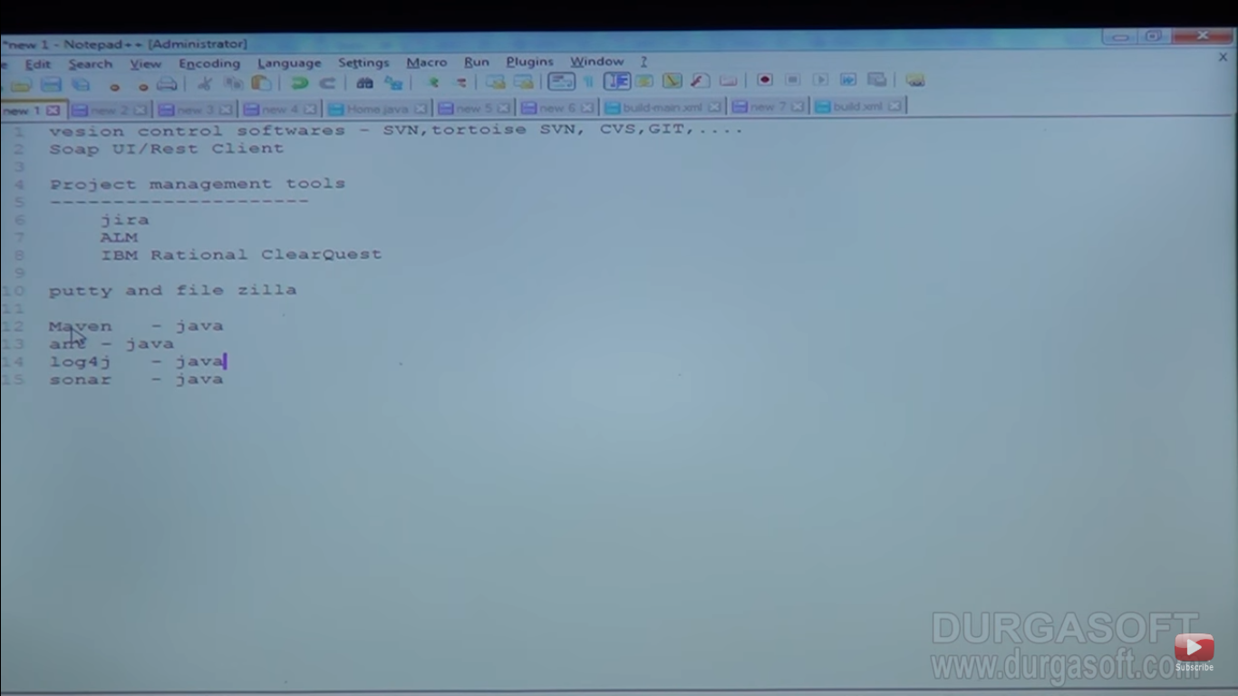

Creating ant project:

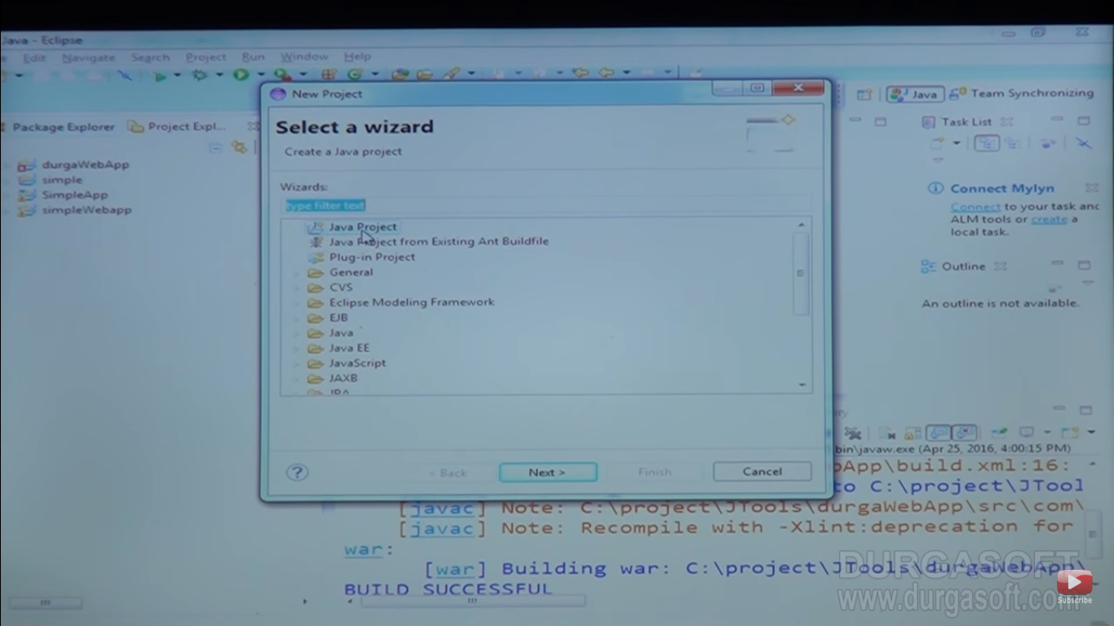

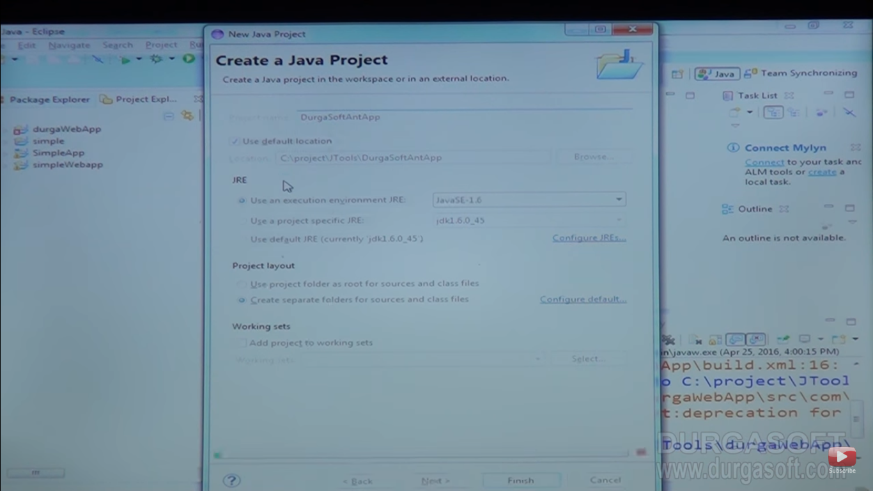

Going to write ant script:

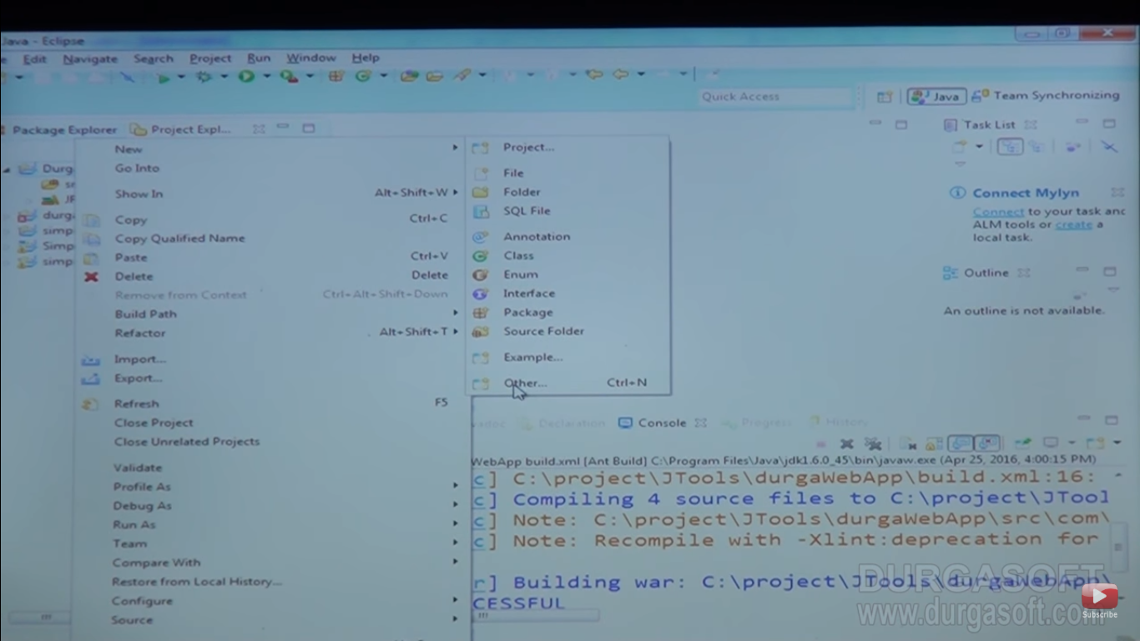

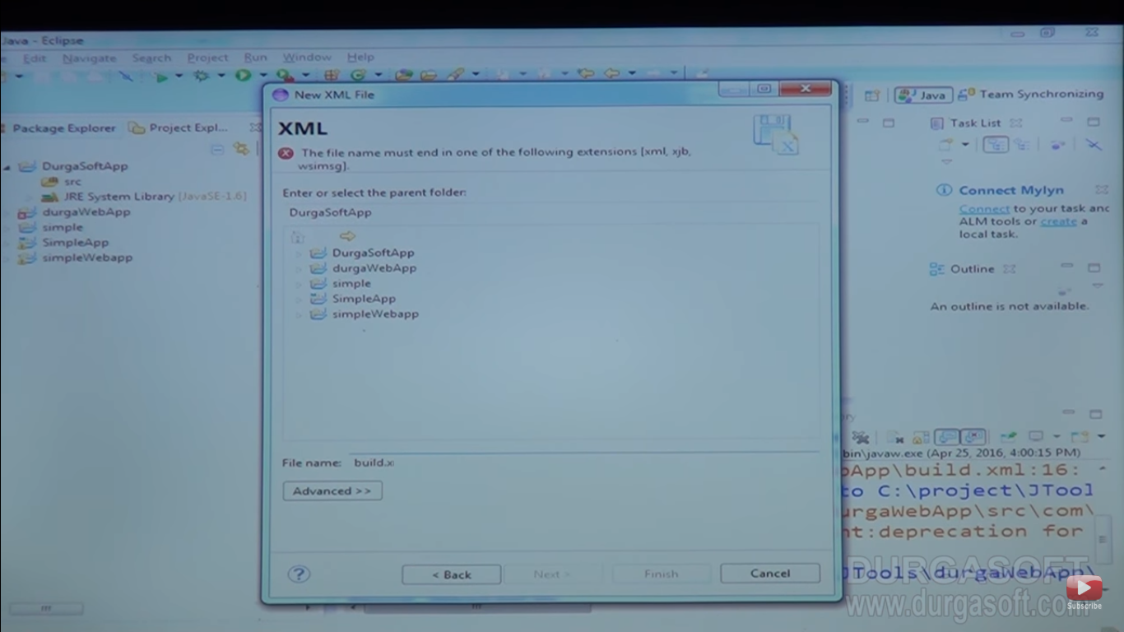

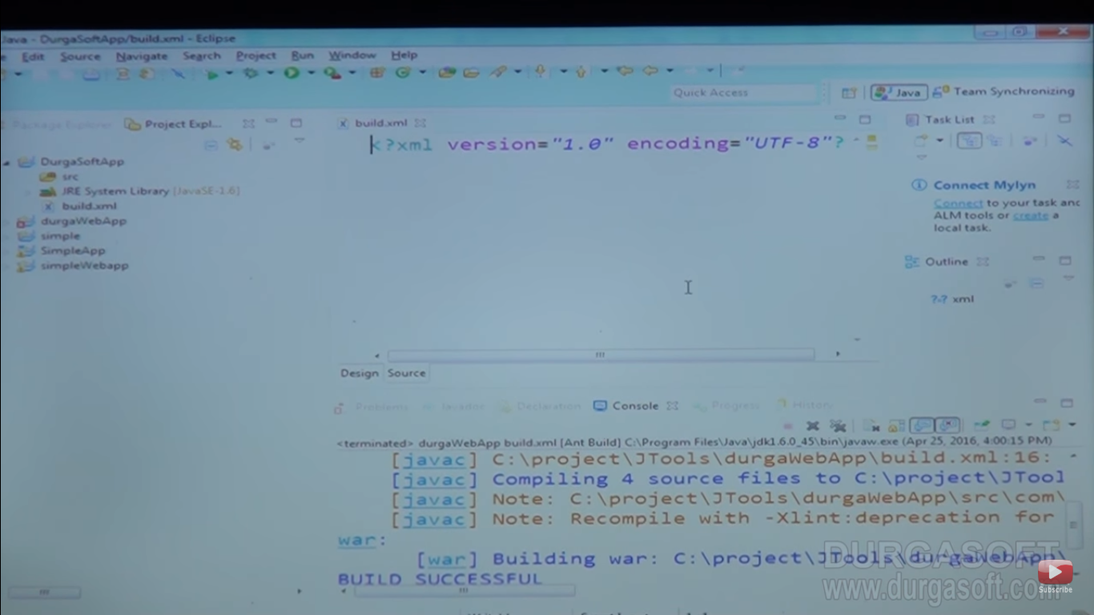

Starting syntax

<project>

<target>

<\target>

<\project>

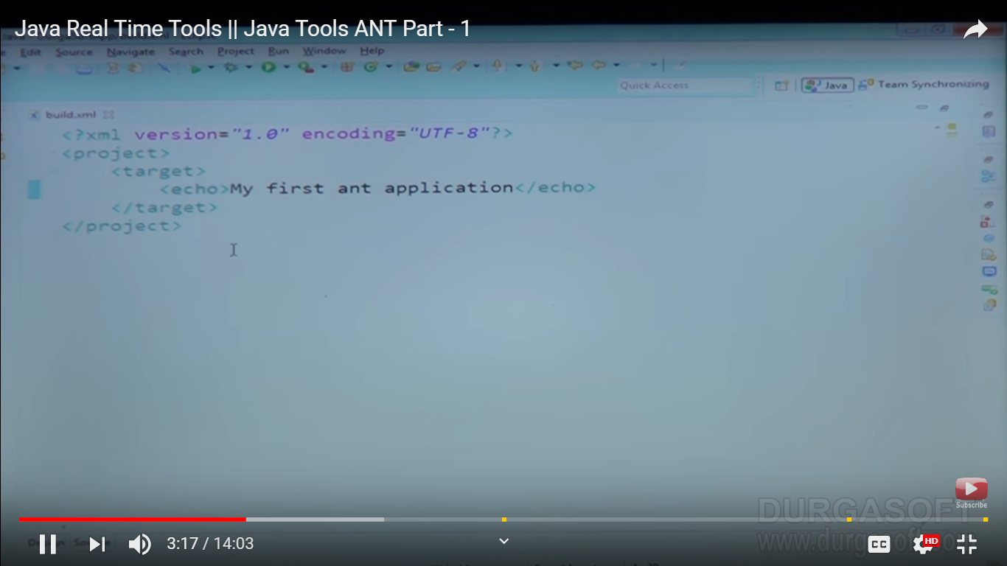

Build got failed need to give name of project

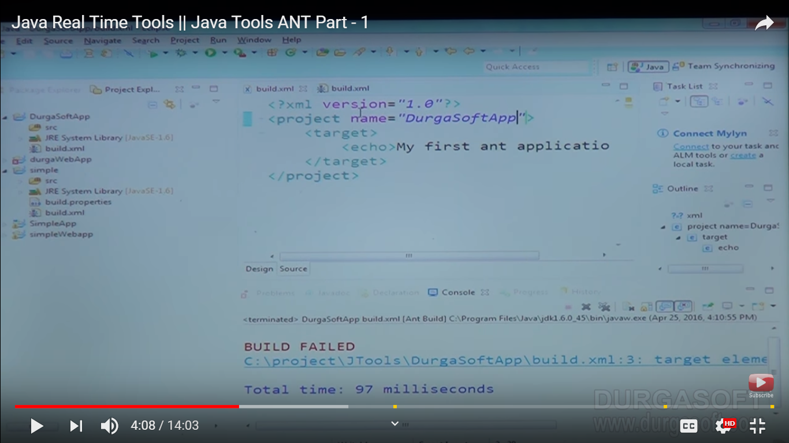

Give target name also

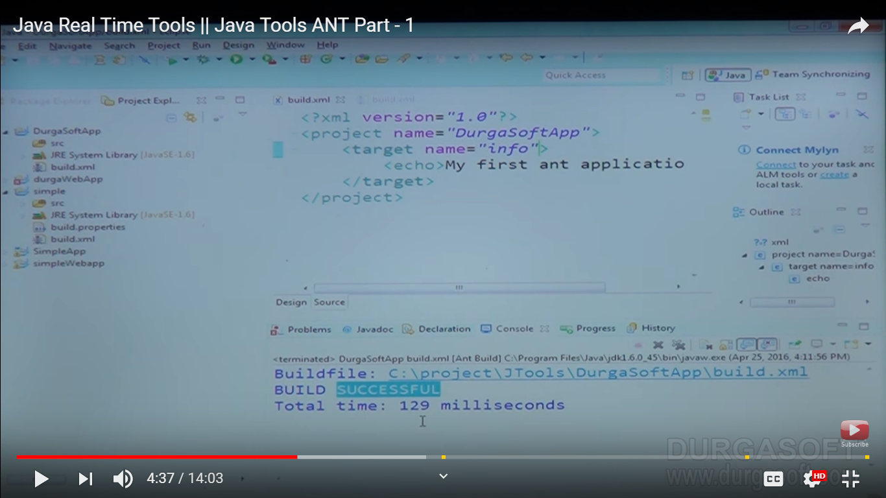

Nothing is printed because target(info) is not executed

Let see how we can execute this target

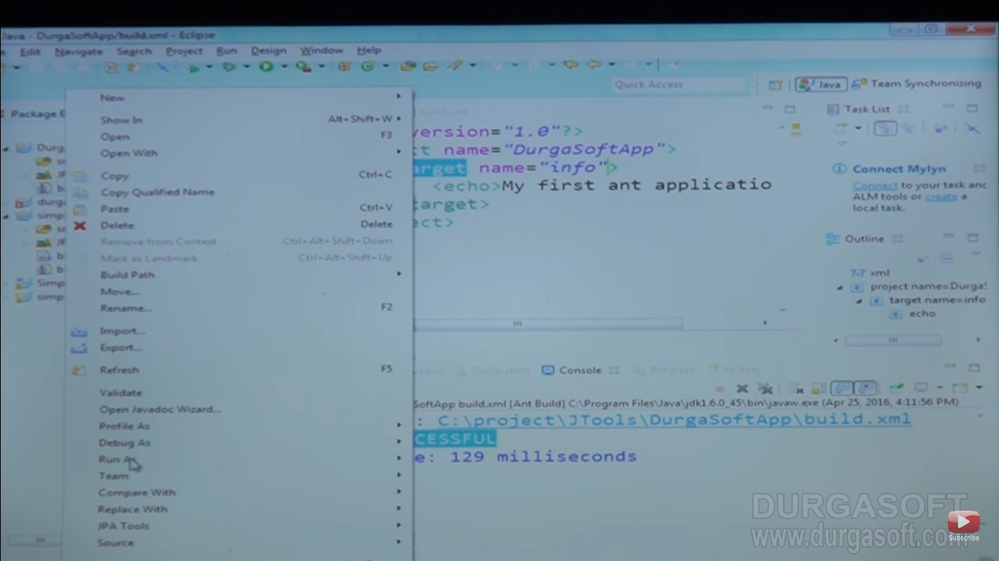

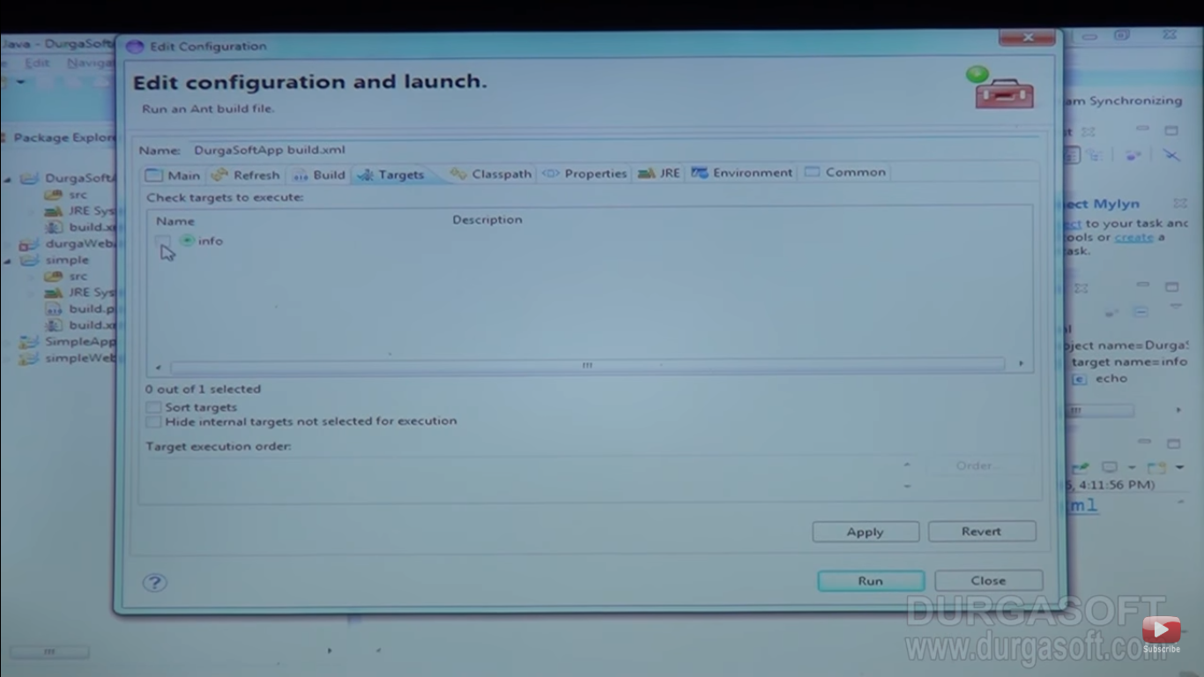

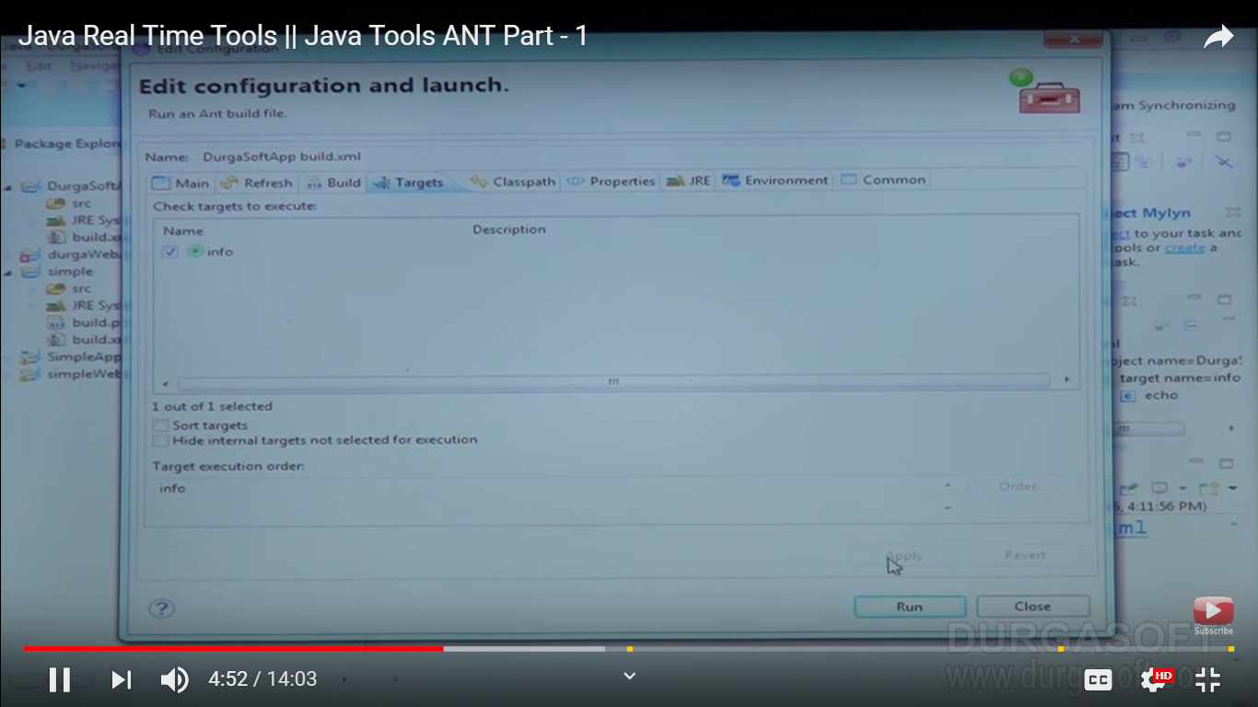

Put run and apply

Note : Ant is scripting tool

Suppose we have some more target like clean,compile,info,pakage ,deploye

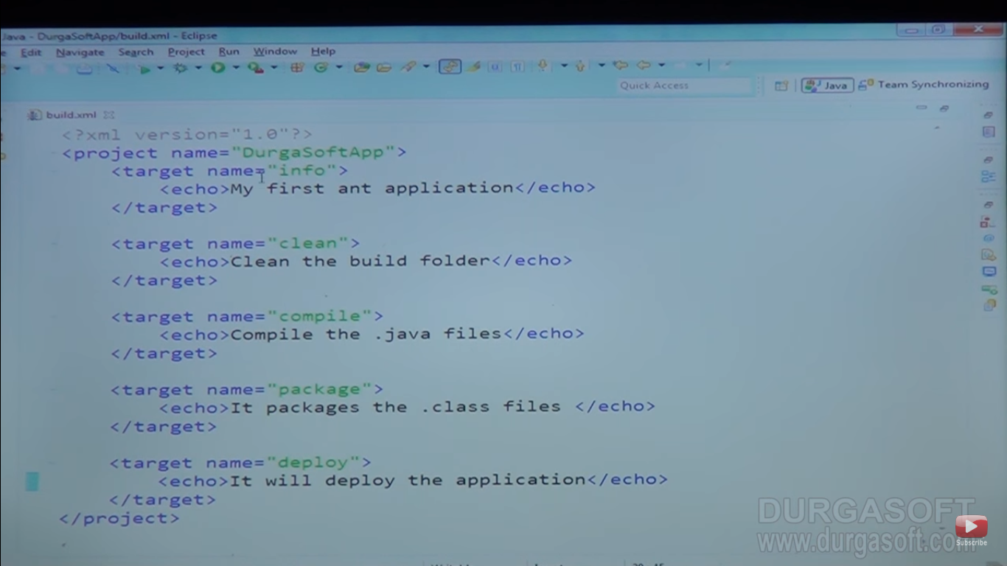

Only select clean as target

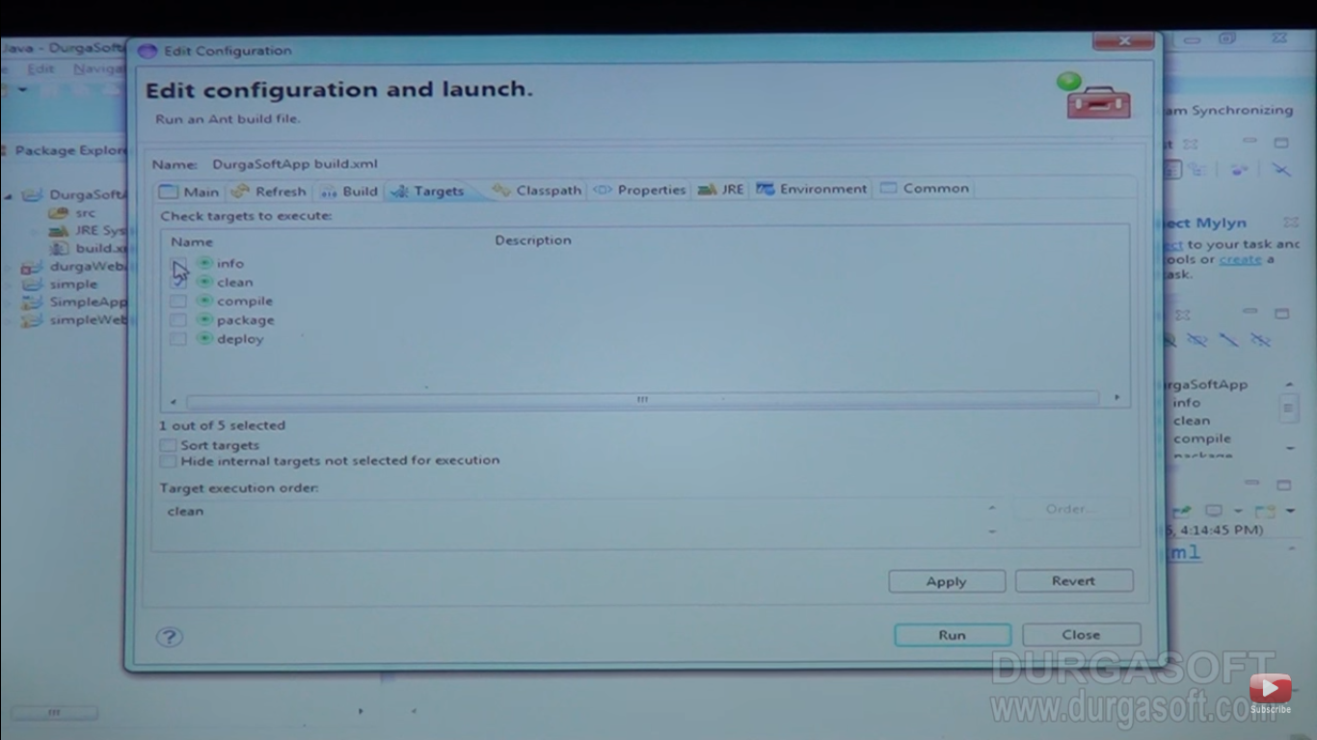

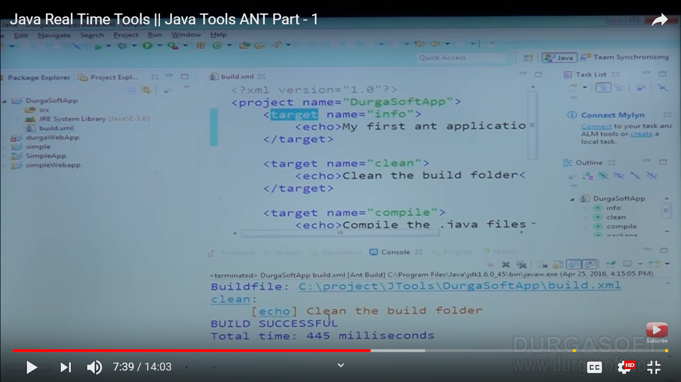

Choose all for doing action to execute all targets

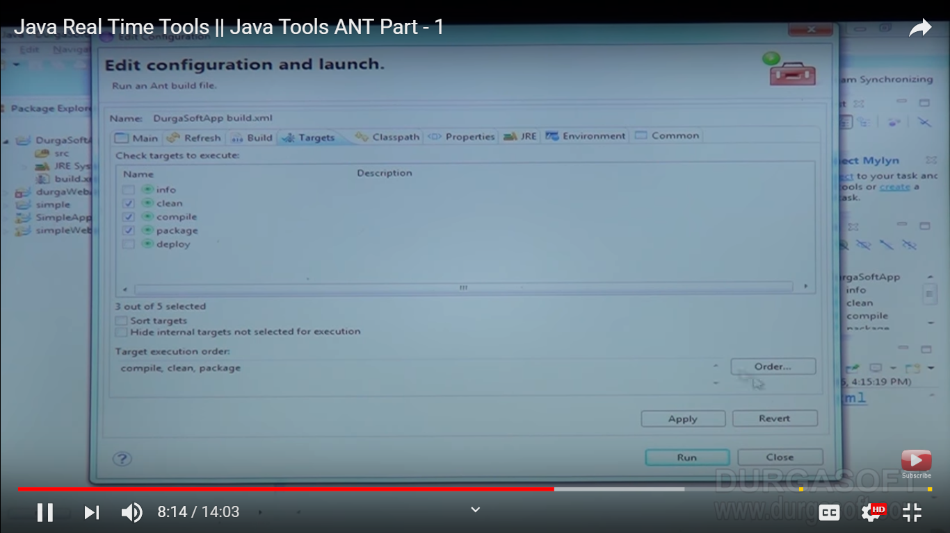

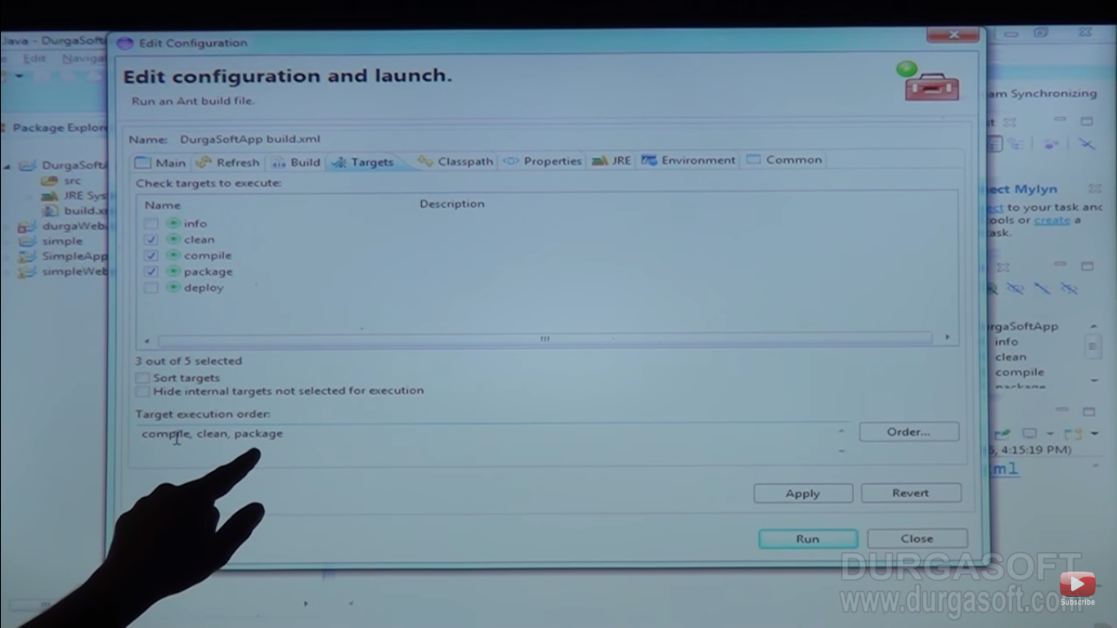

You can chose order also

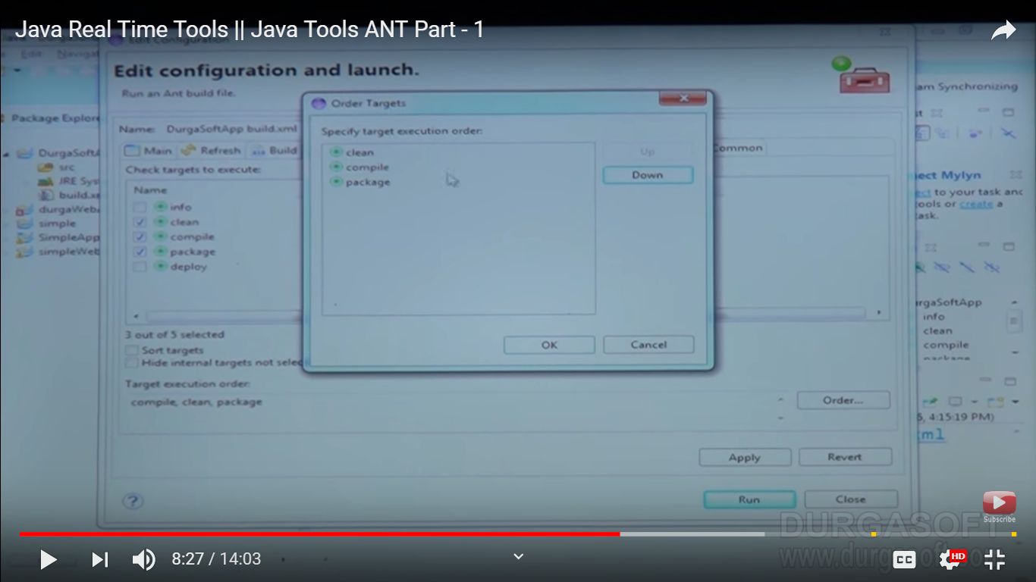

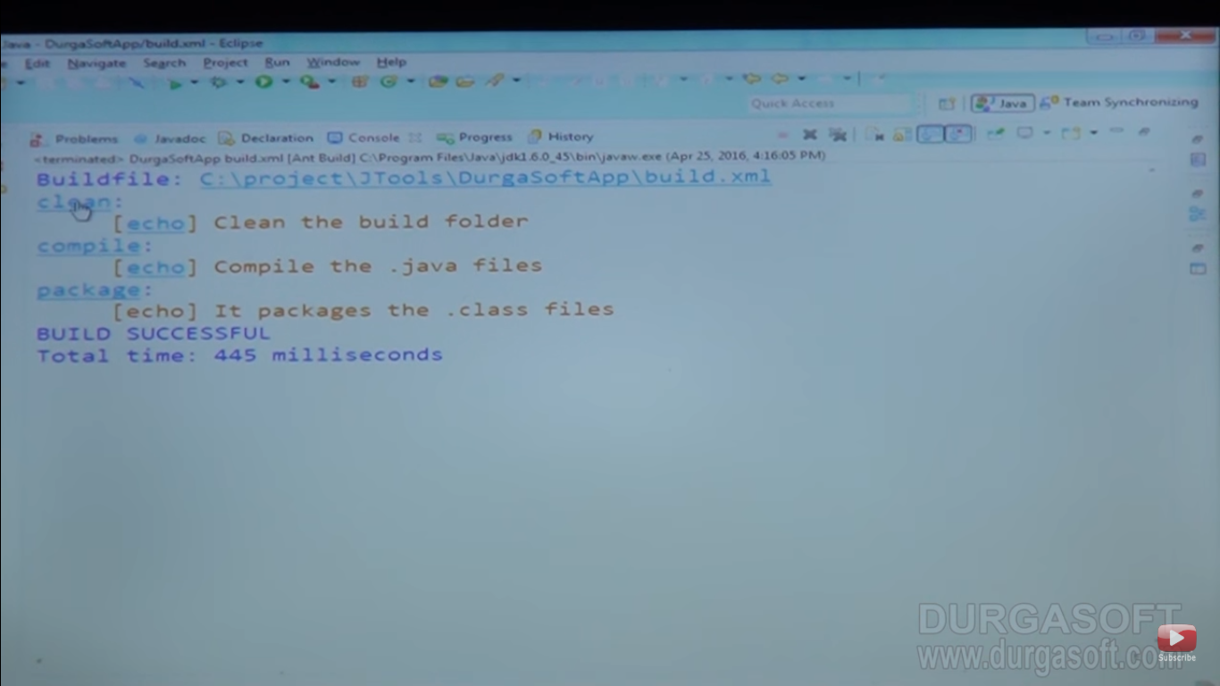

Depends Key word:

Note : After all dependency will execution then target name info will executed

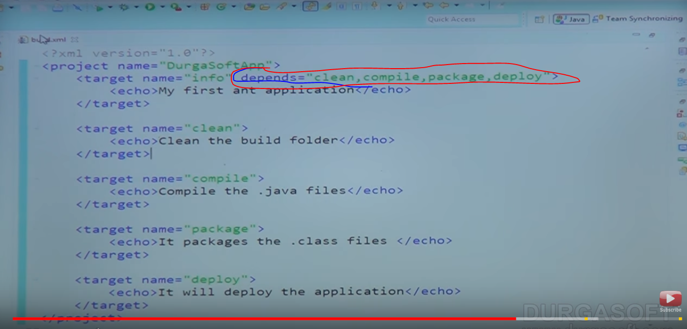

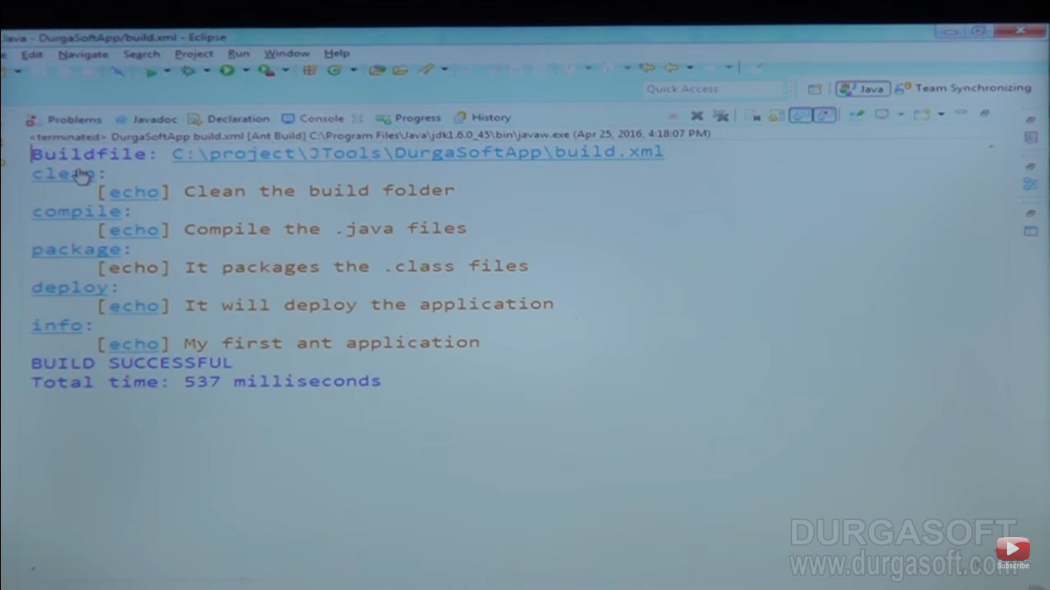

Creating dist folder

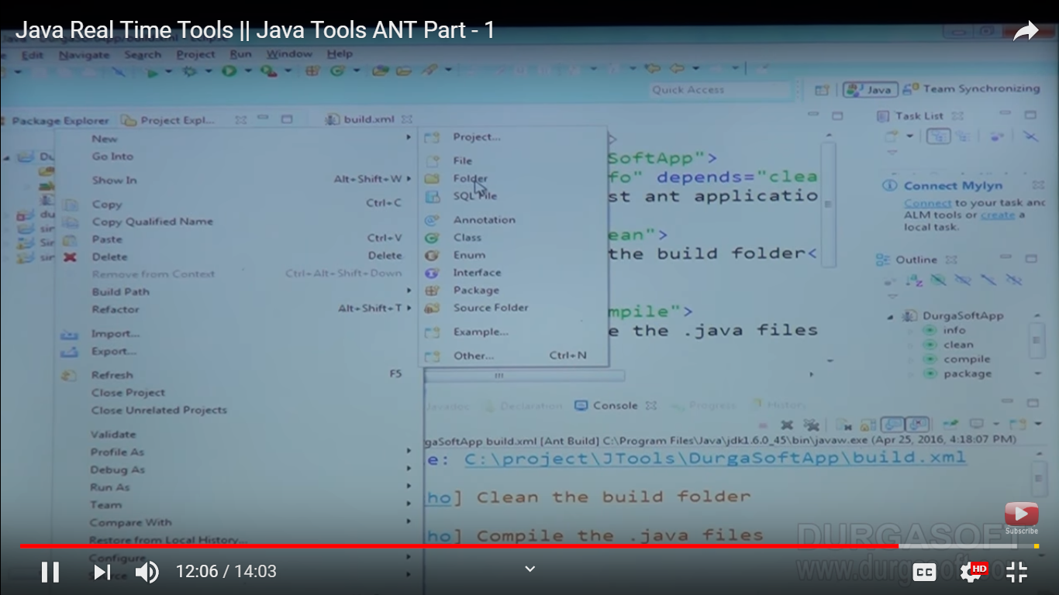

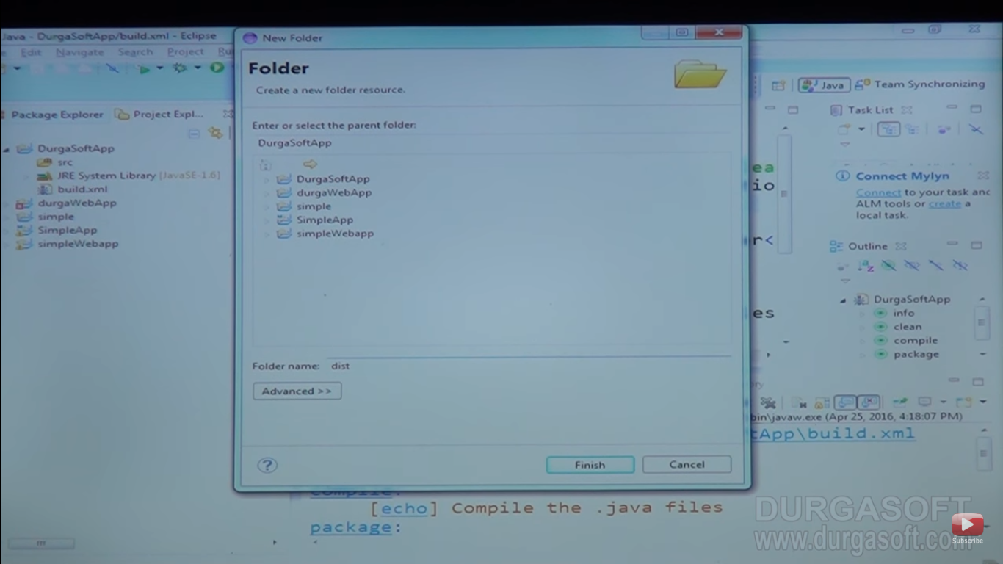

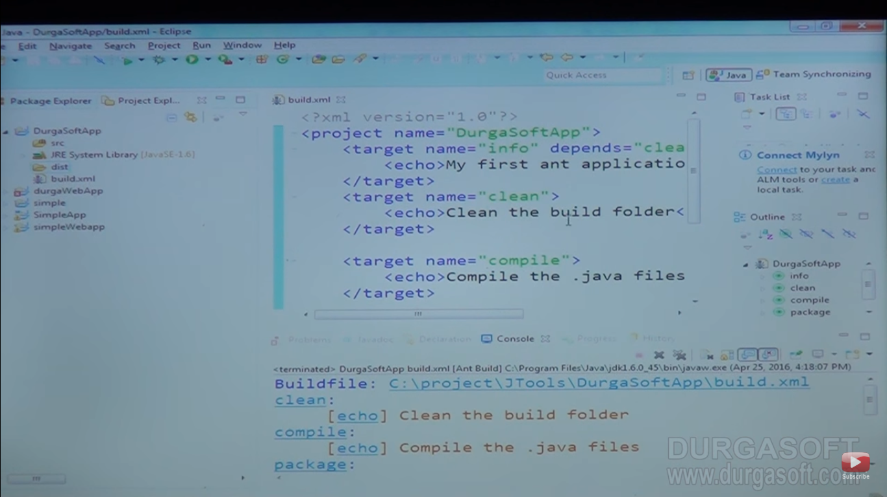

Suppose dist has some file

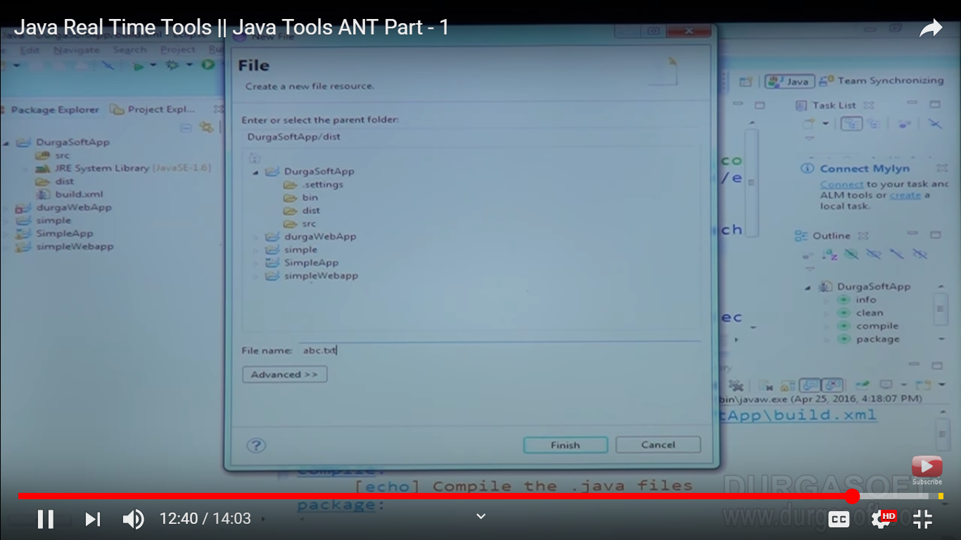

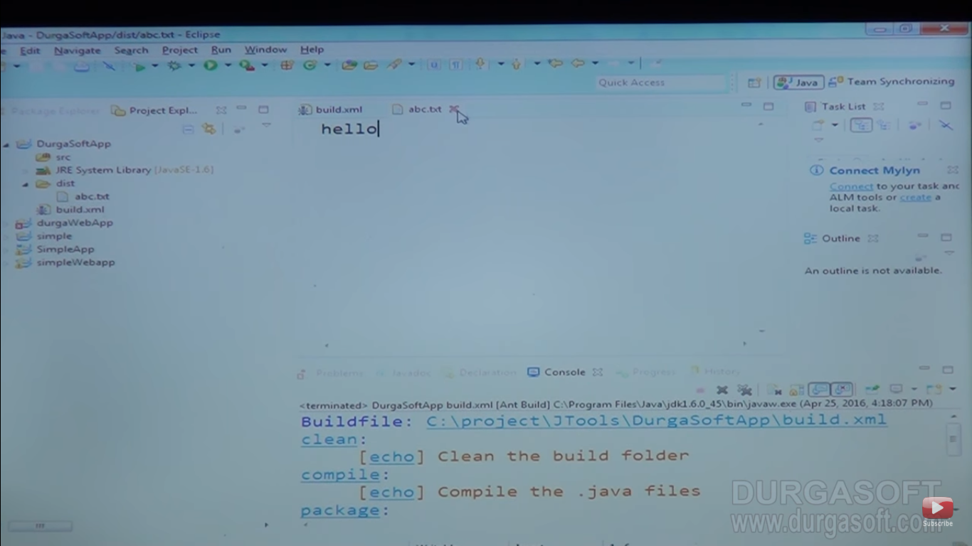

Clean target clean the dist folder

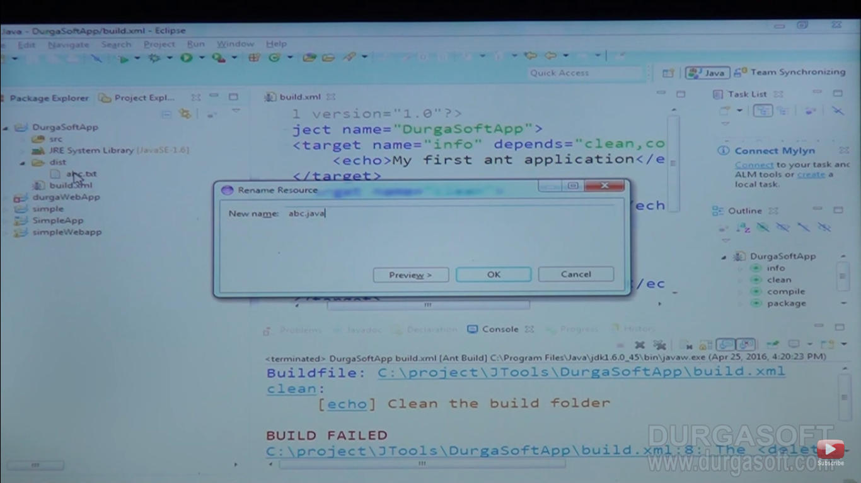

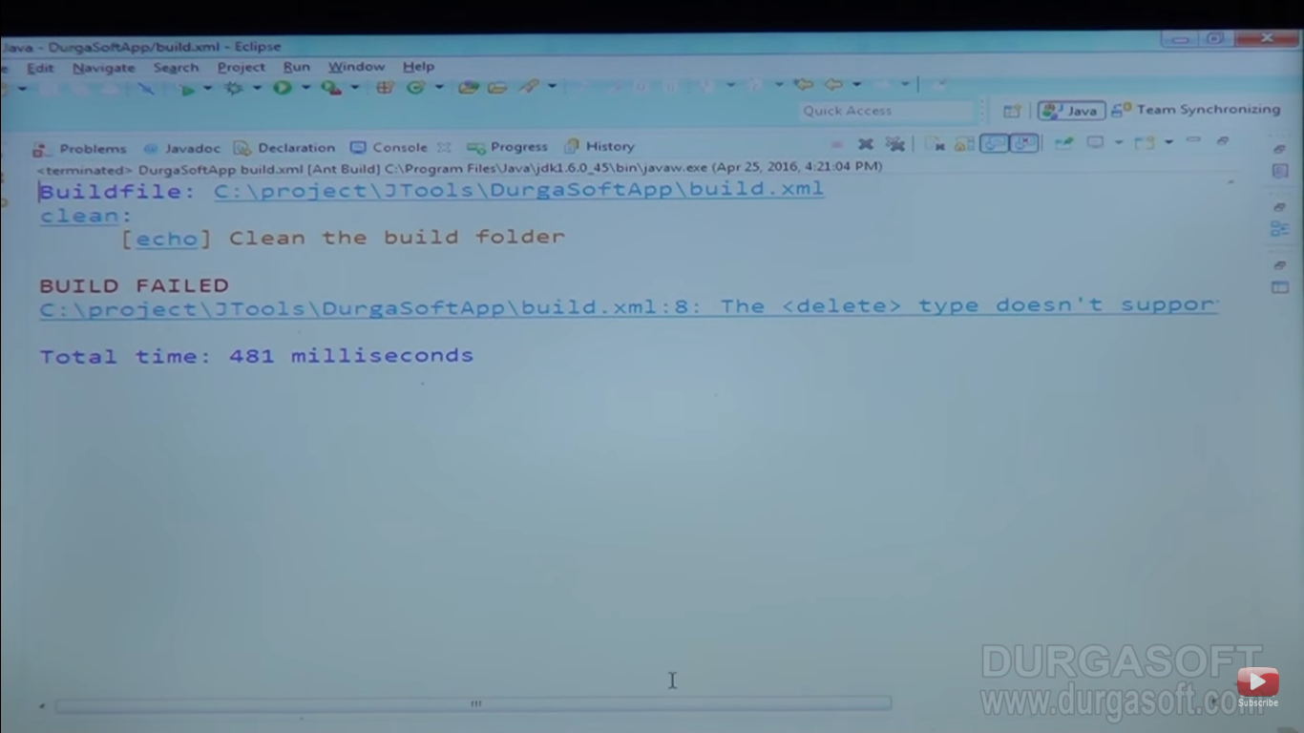

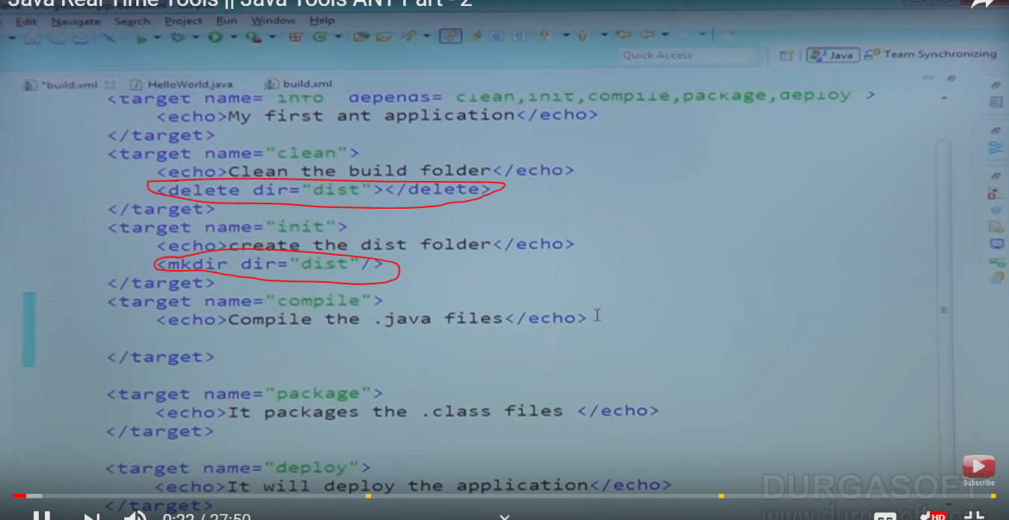

Imp : target name compile

<javac destdir=”dist” srcdir=”src”></java>

That means it will go to src folder take that java file compile it and place it inside in dist. folder

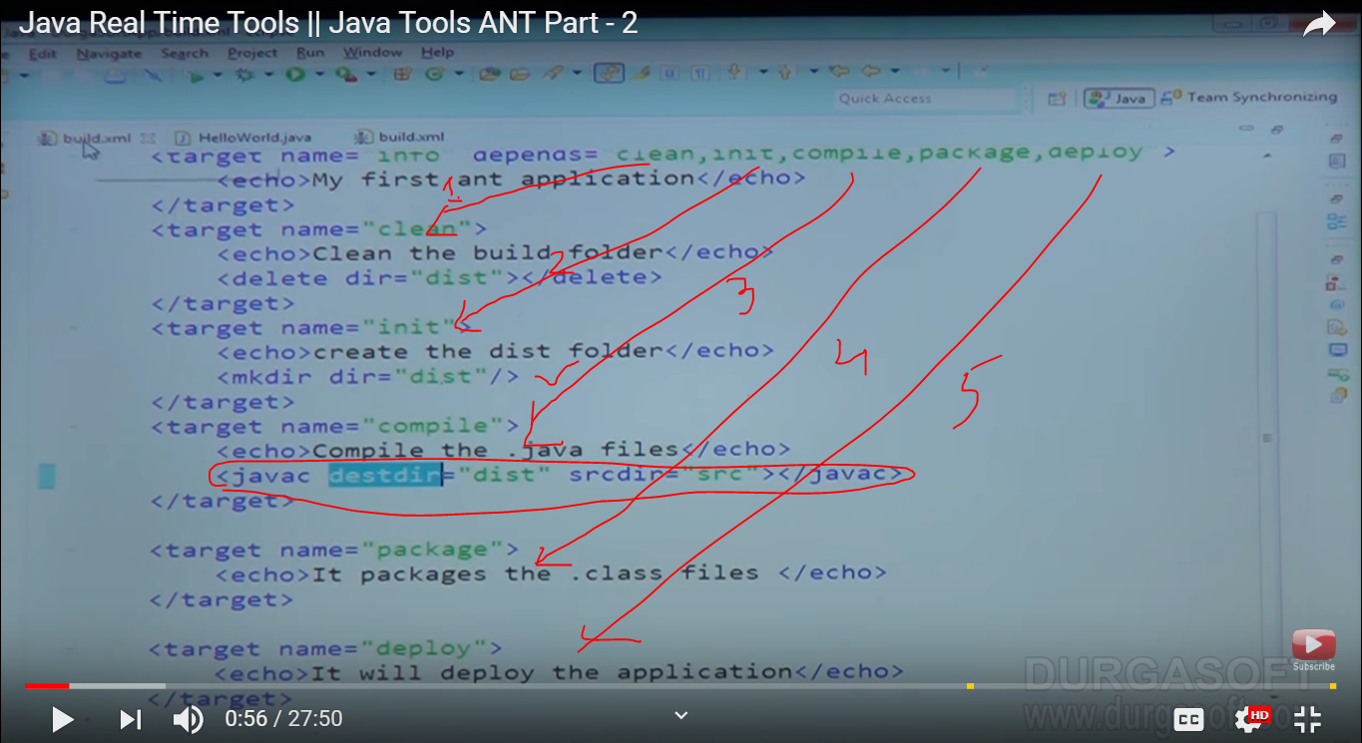

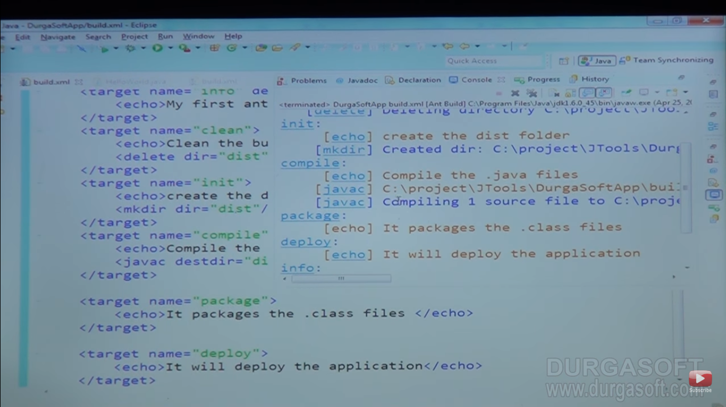

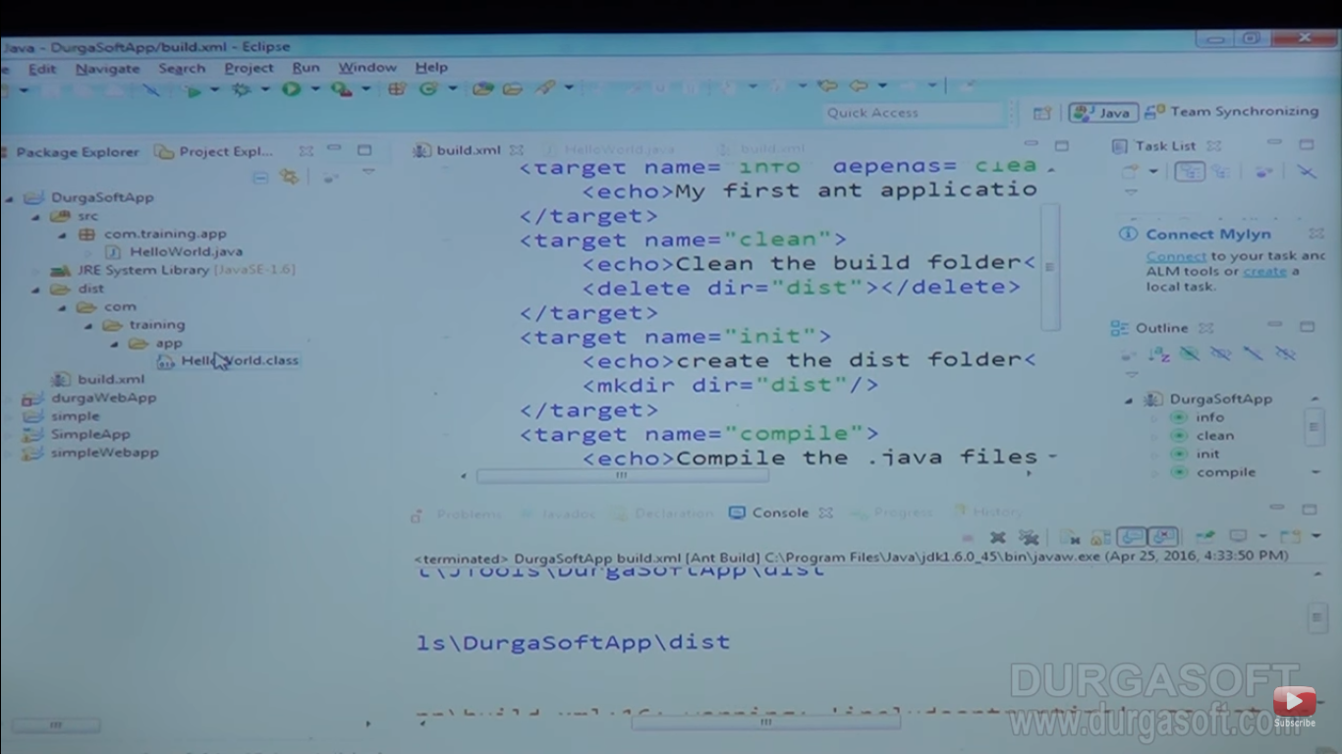

Now packaging :

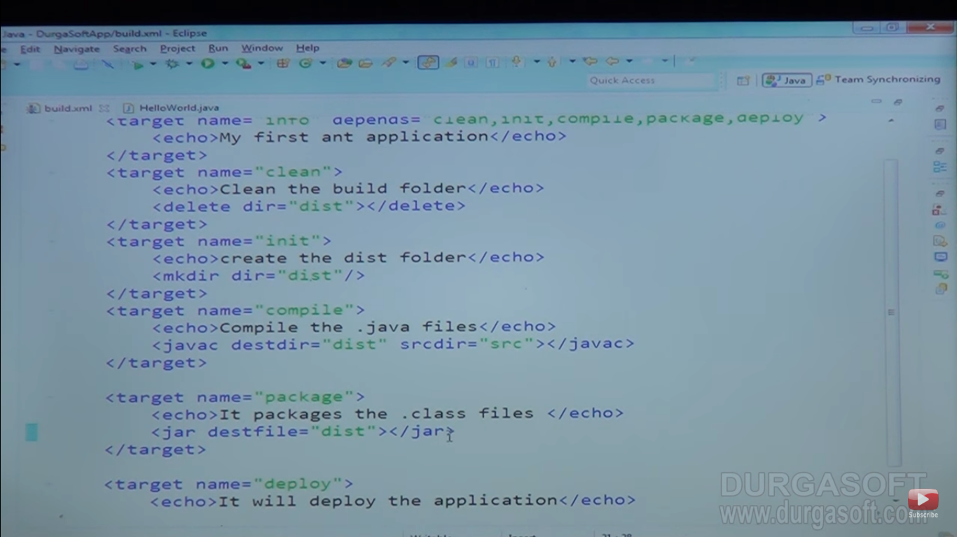

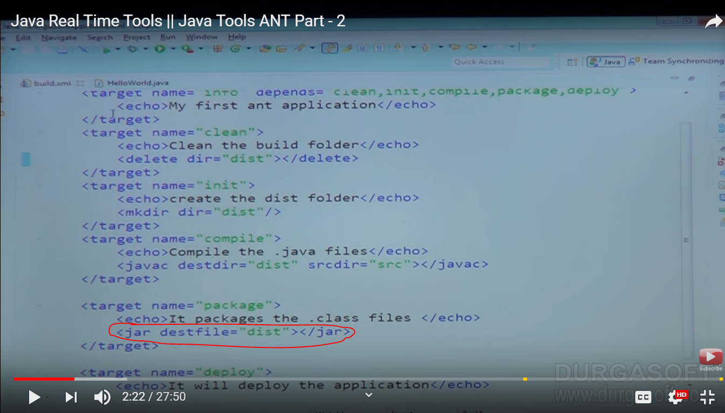

Remove dist. folder so you can see effects

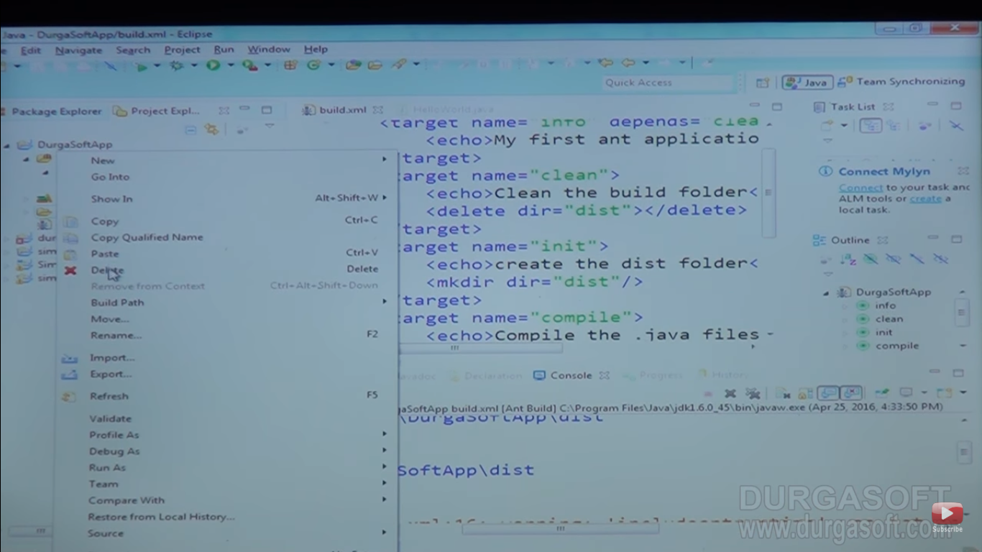

Now build it

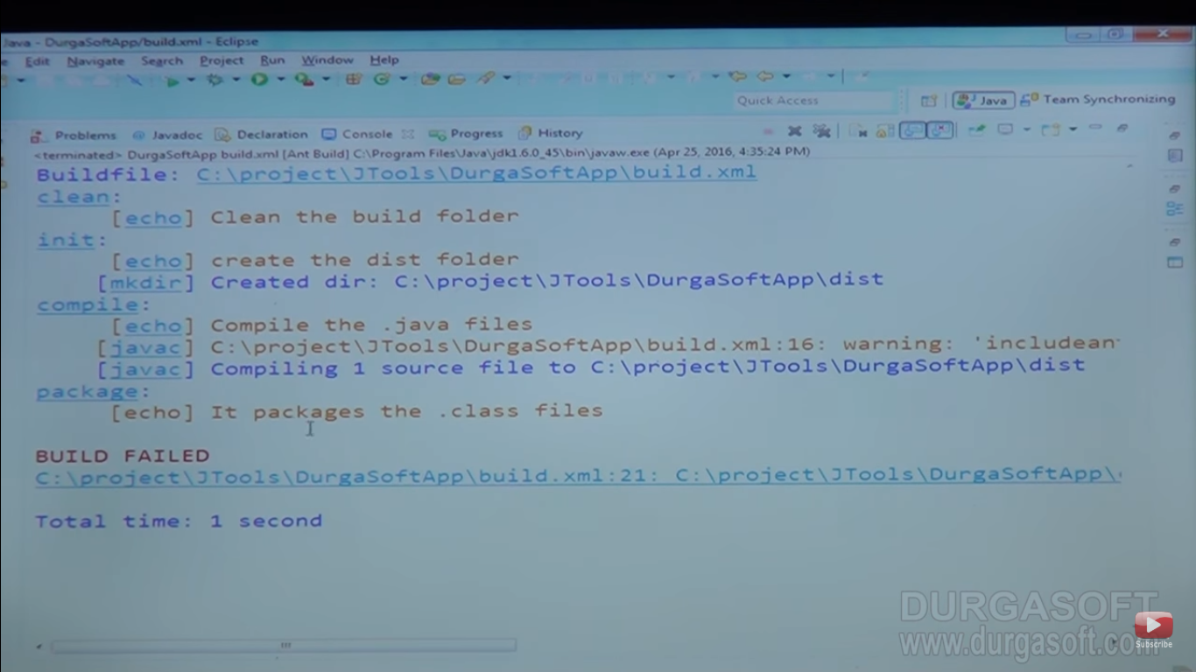

Now change the destfile statement (Because it will look a file not folder)

<jar destfile=”dist/*.class”

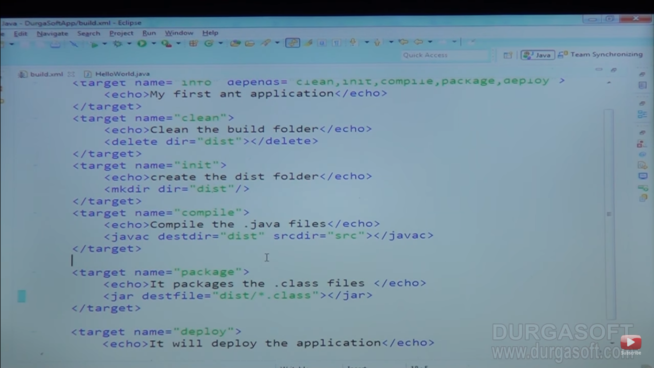

Now again run it

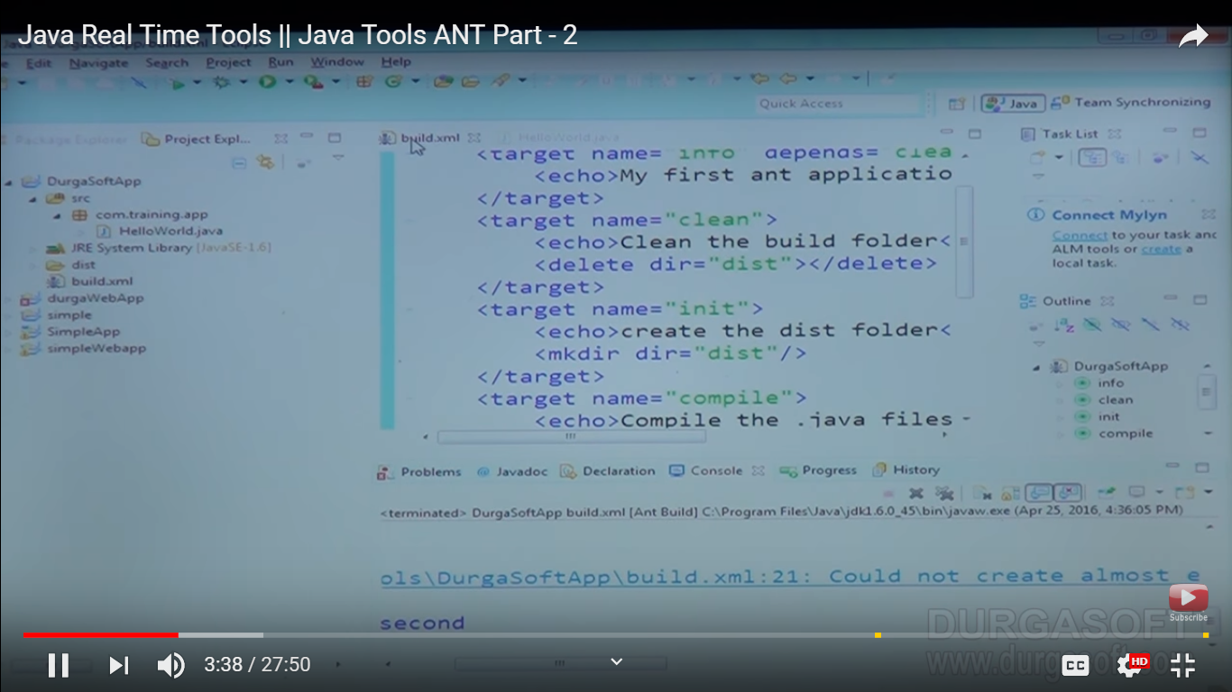

Build failed because in dist folder files are in package format

So need to give proper format

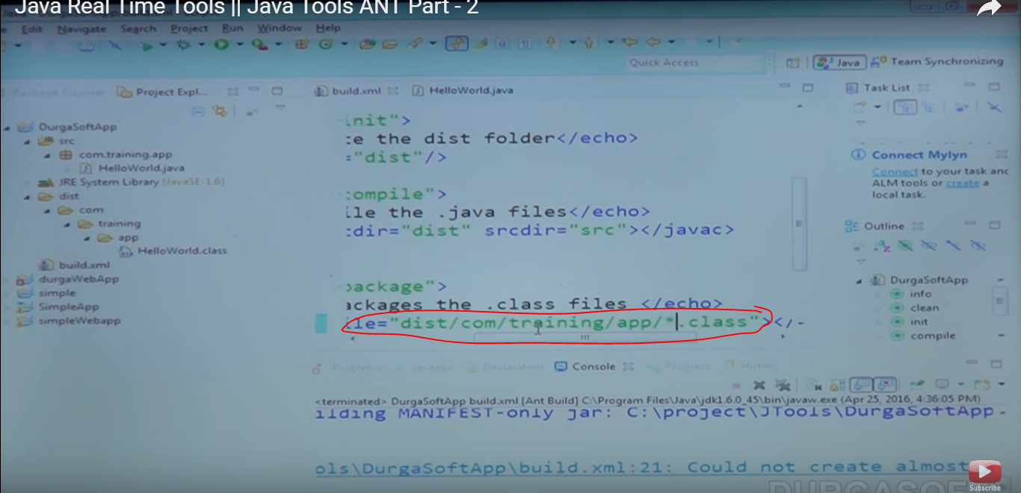

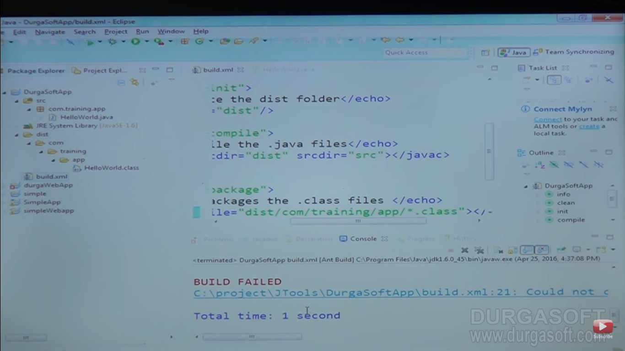

Build is again failed because of package target so first need to put base directory and destfile location where you want to create

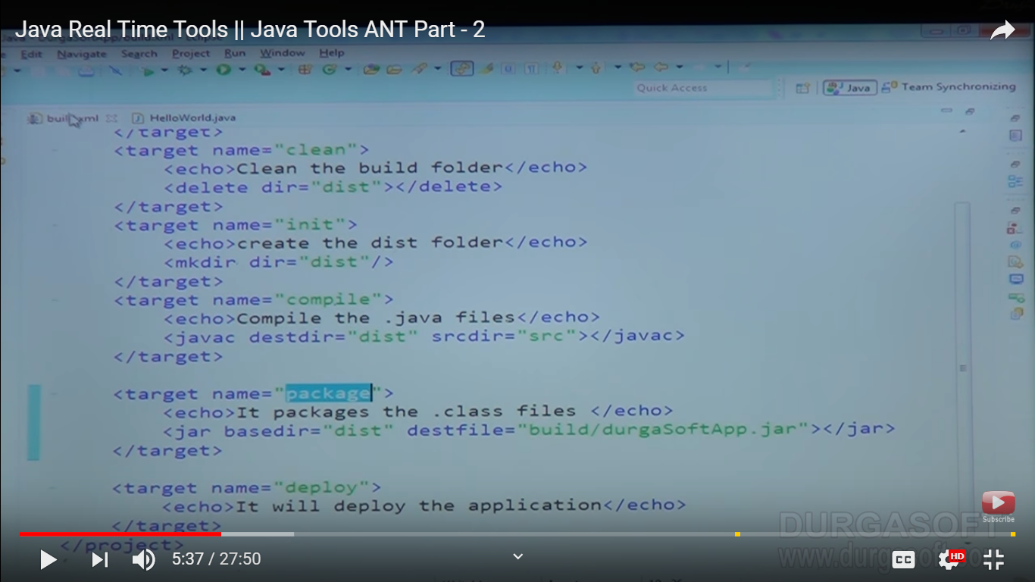

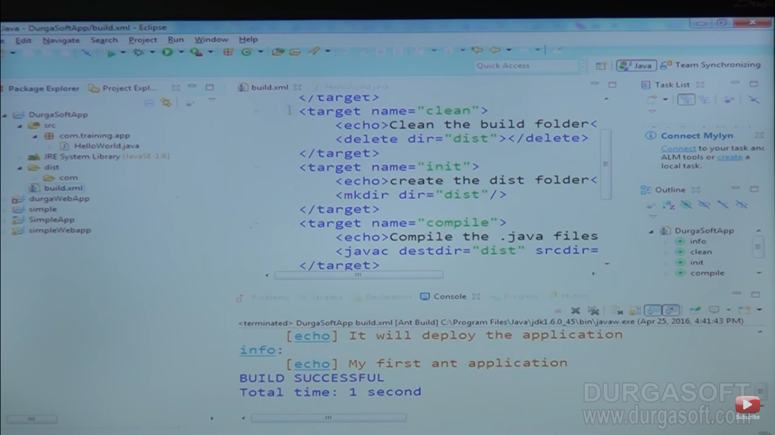

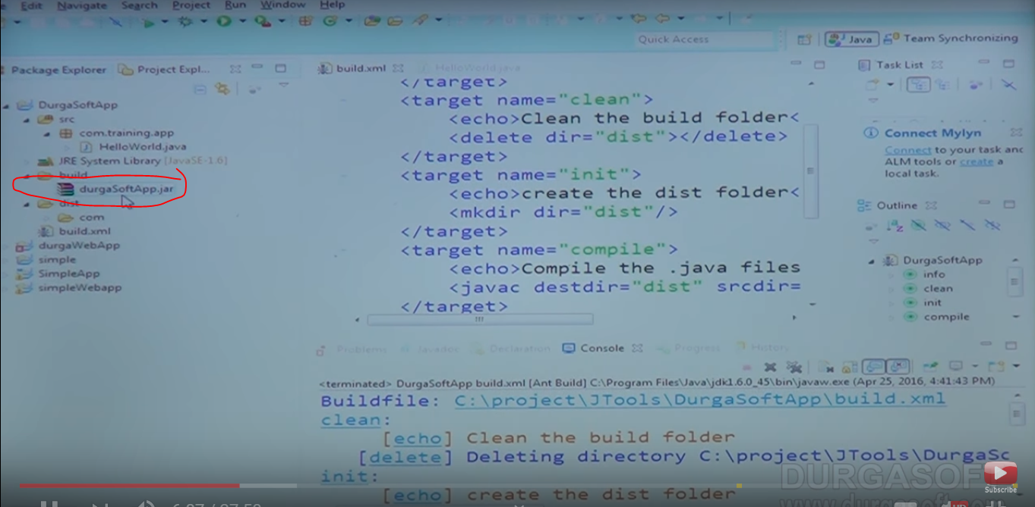

Now deploy : need to place in apachetomcat/lib

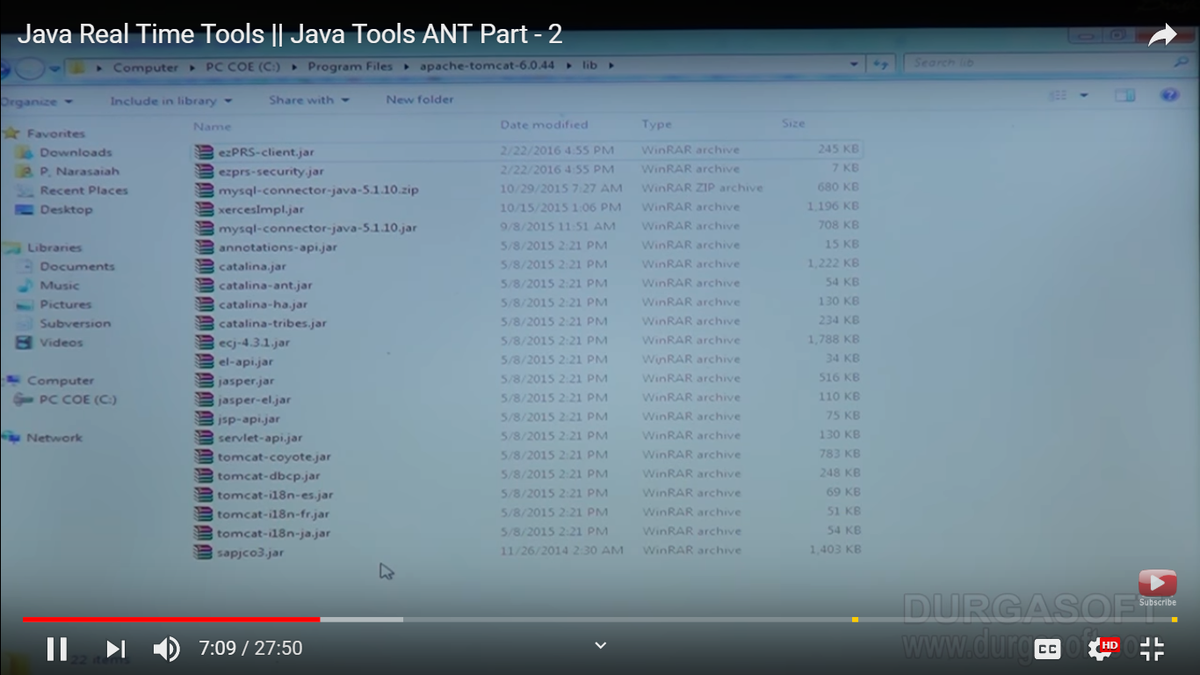

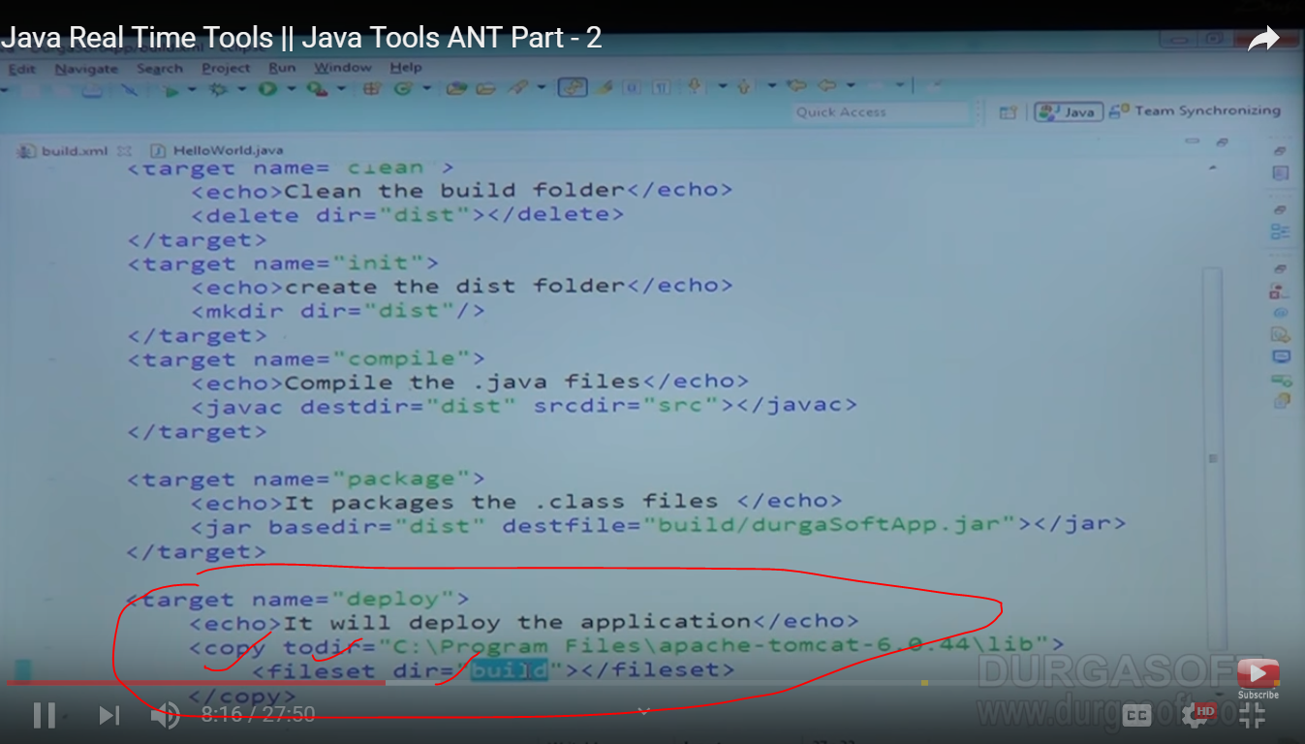

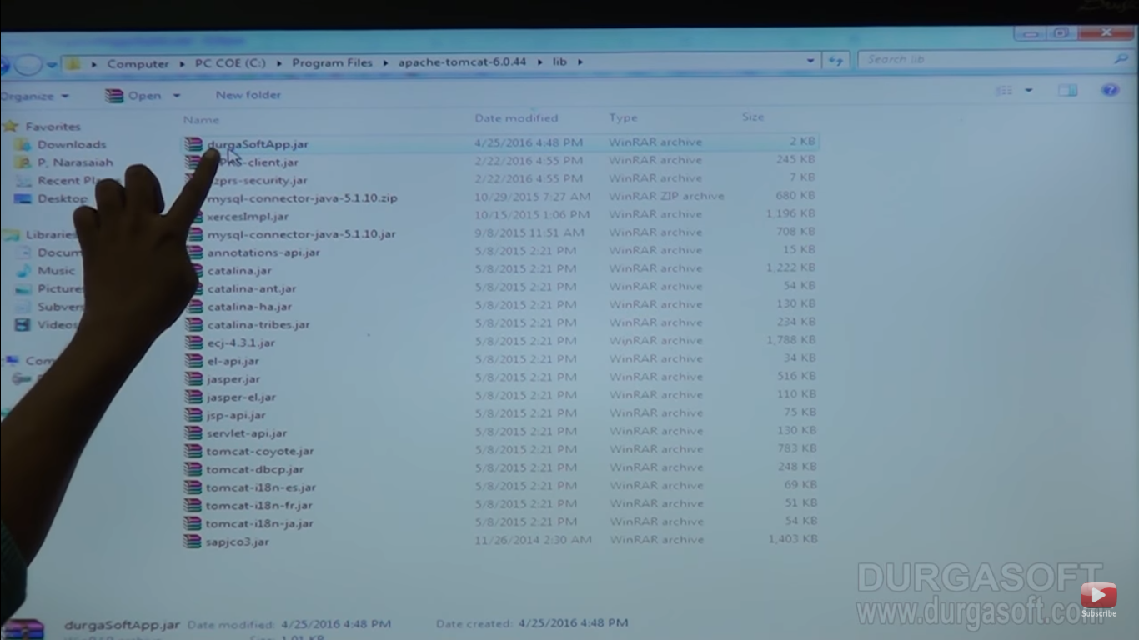

Conclusion:

**depends 🡪 first excuite one by one**

**delete 🡪 for deleting folders**

**mkdr 🡪 creating folder**

**javac and destdir,srcdir🡪 for compiling java file and placing into destination folder**

**jar and basedir, destfile🡪 for packaging**

**copy and todir, fileset🡪 for deploying**

For Dynamic value ${ant.version} its environment variable

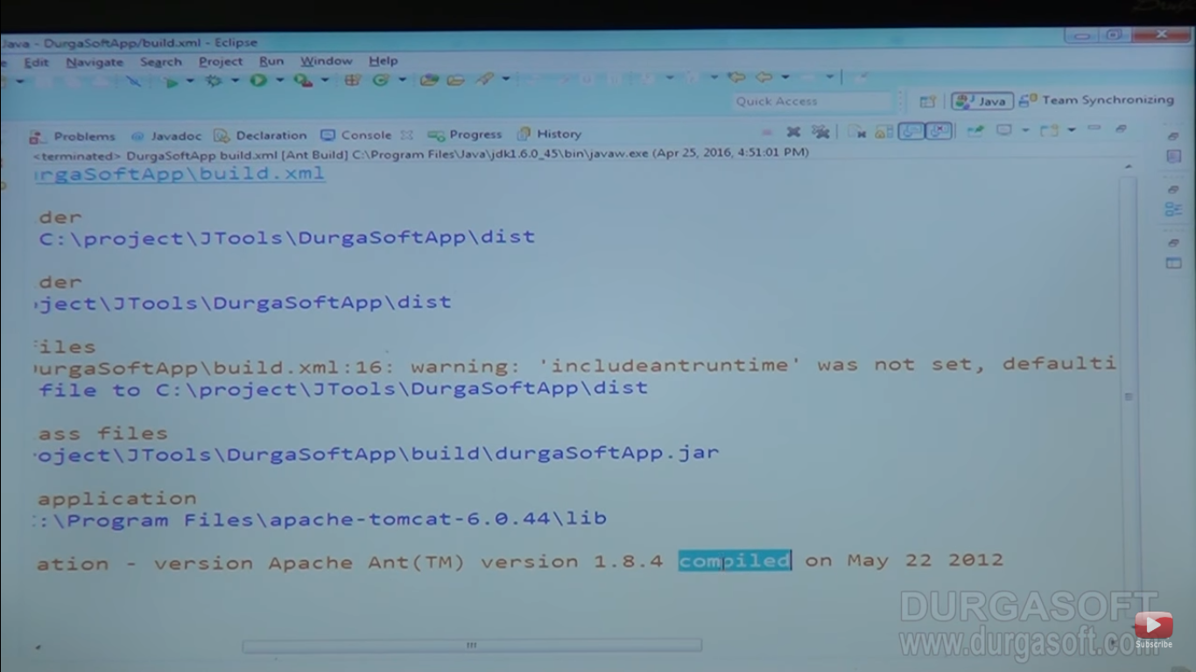

Default environment variable that you can add during build file

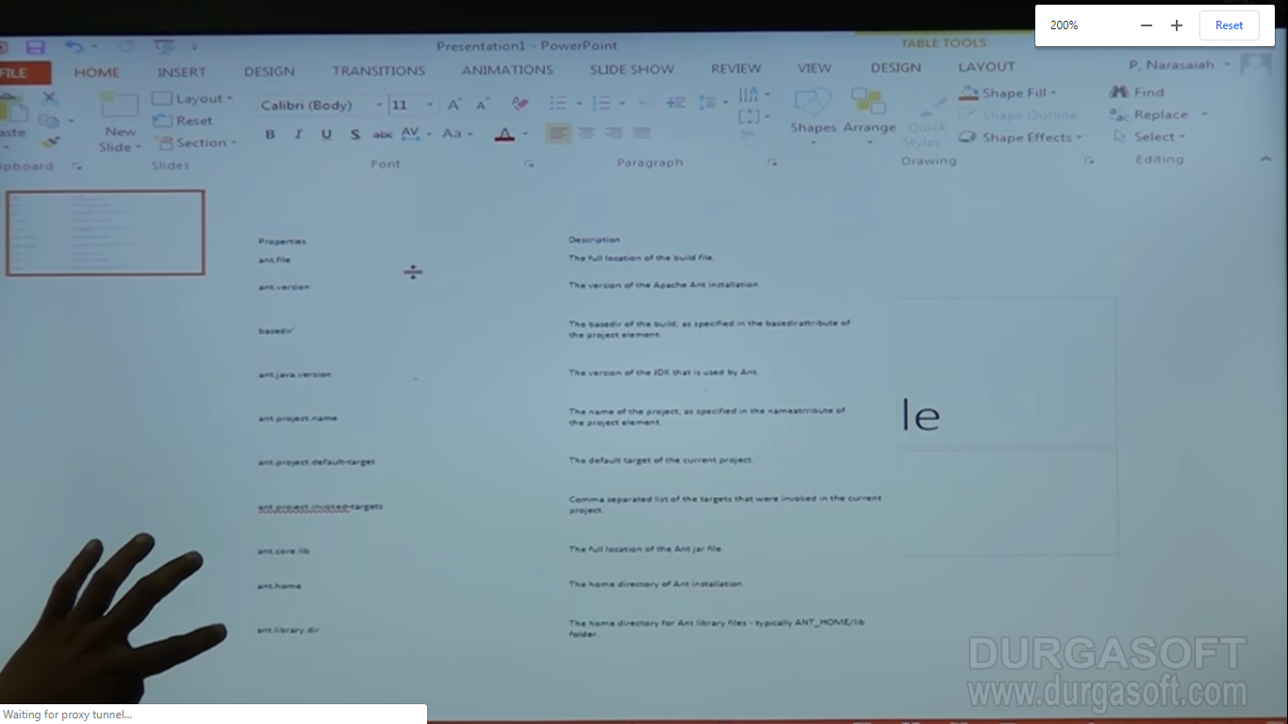

You can print the value by passing the value with $ sambal

Creating our custom properties:

1. Create properties file

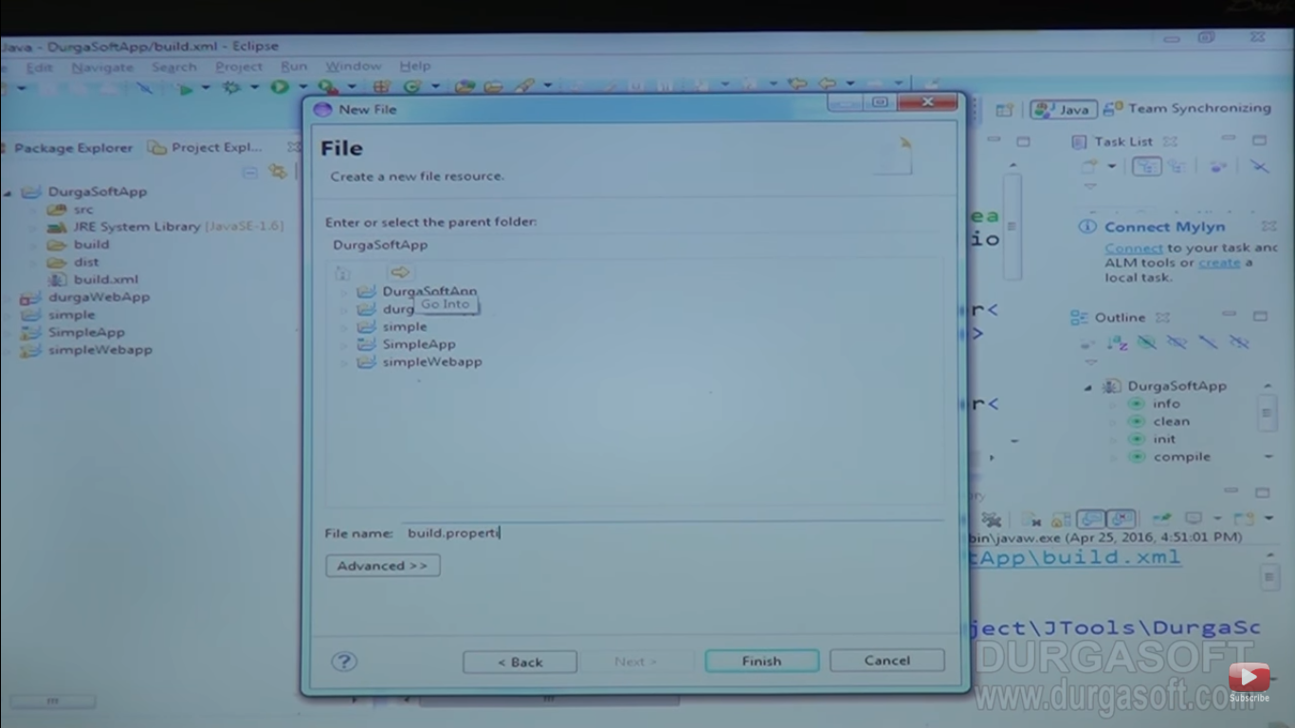

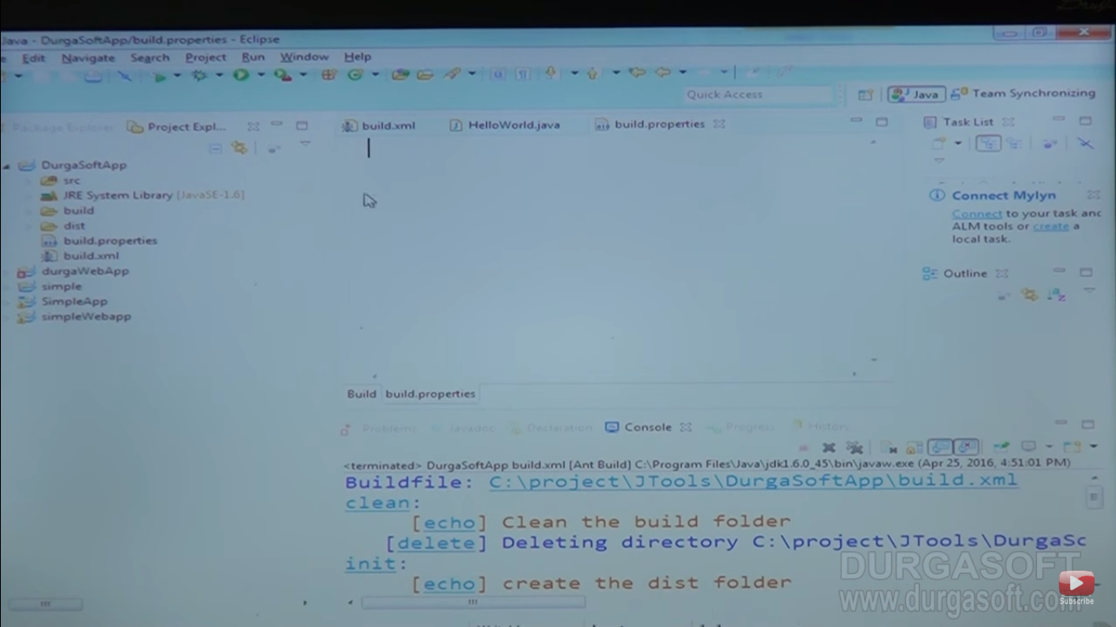

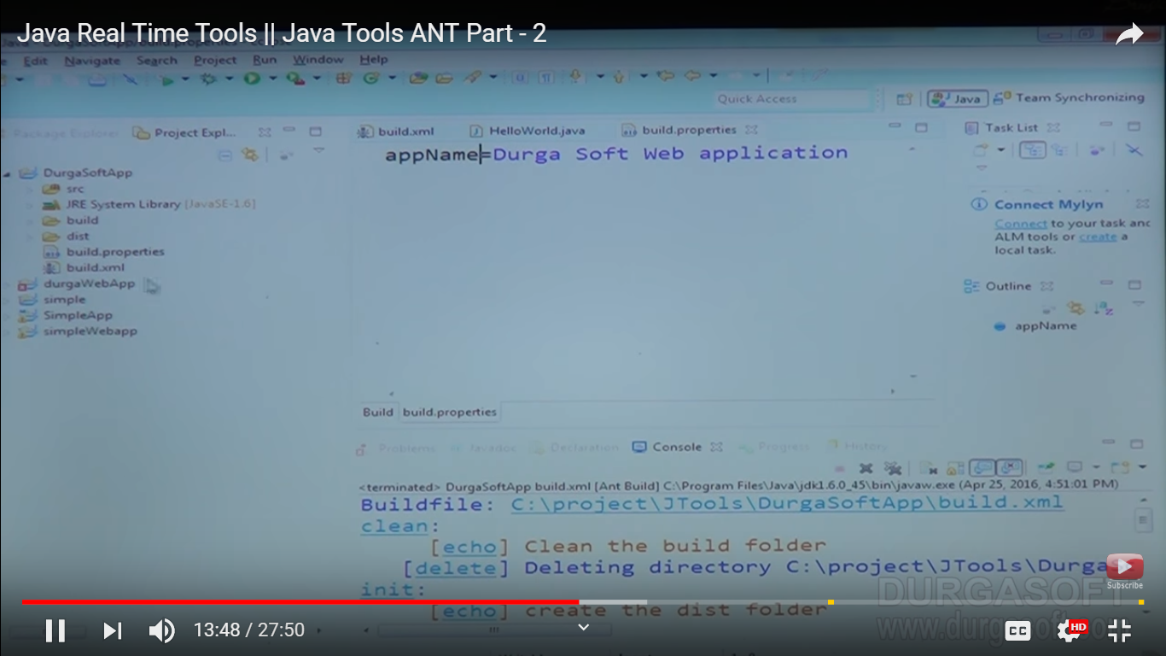

For that you have to specified properties elements in build.xml

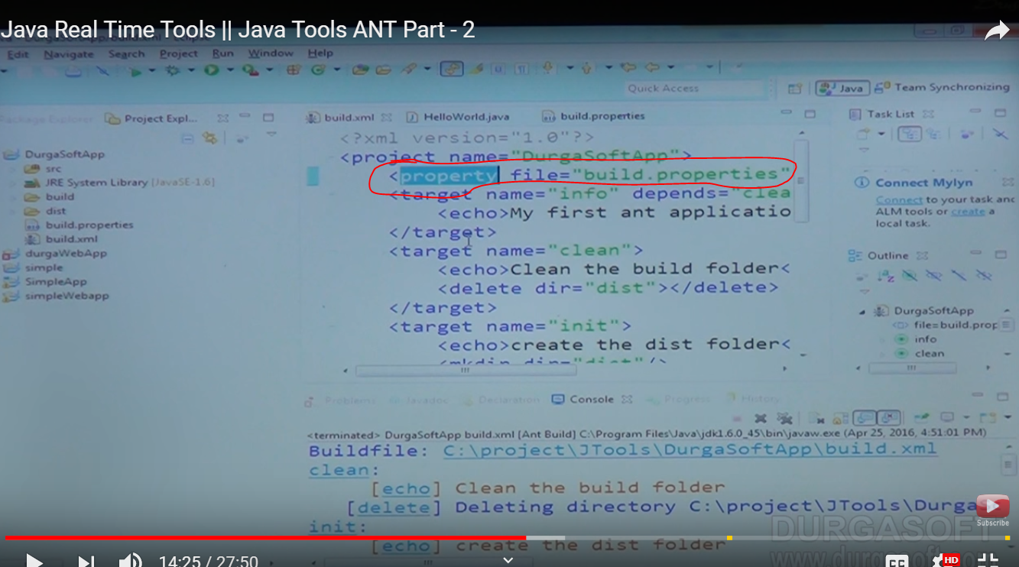

Get print of that value :

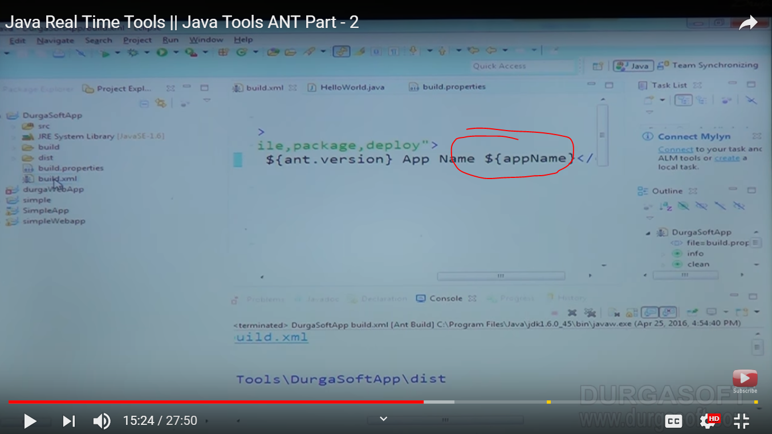

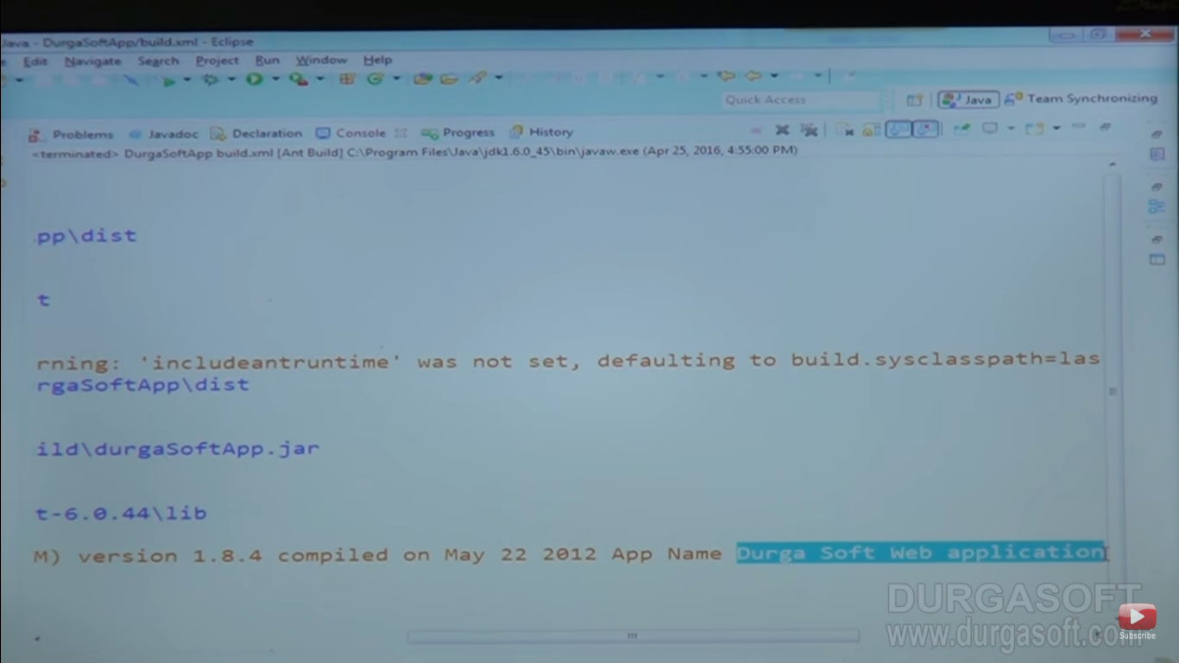

Other web project :

Targets -🡪 init 🡪 compile depends init🡪 war depends compile 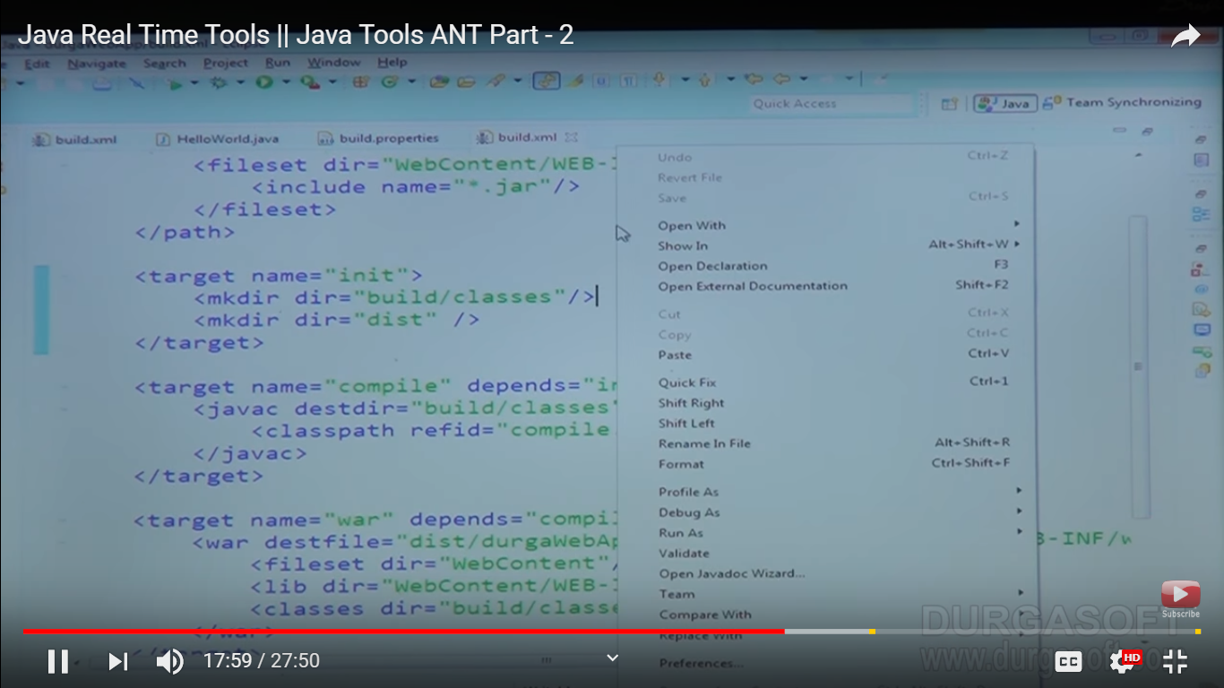

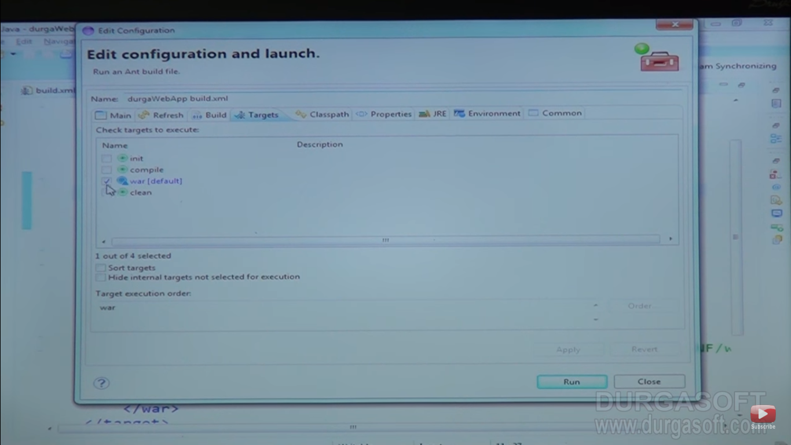

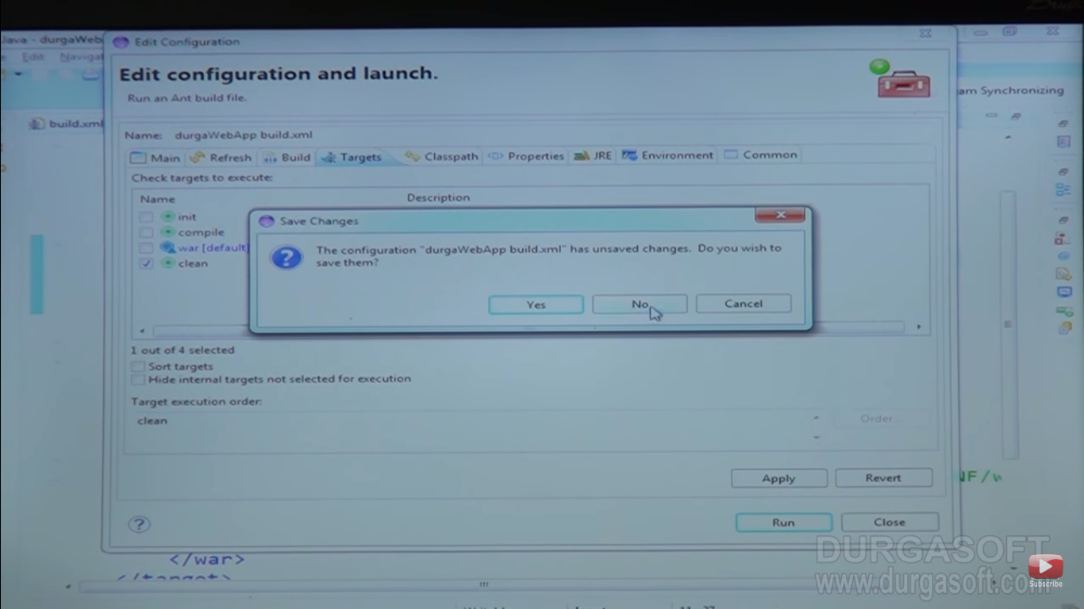

Now if see we choose clean the what clean will do

Delete dirs.

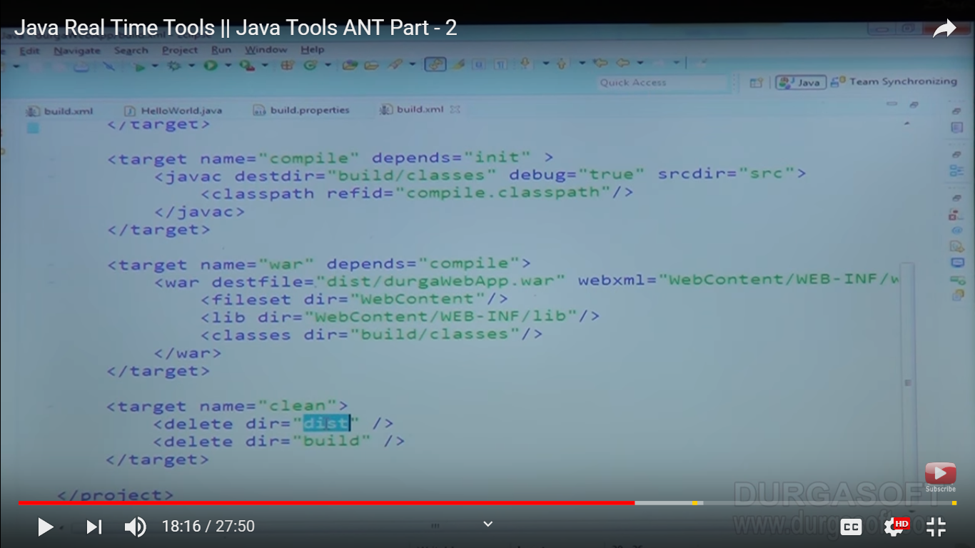

Next excuition of war dir its depends upon compile and compile depends on init so like this it will excuite

Steps : init is excuiting

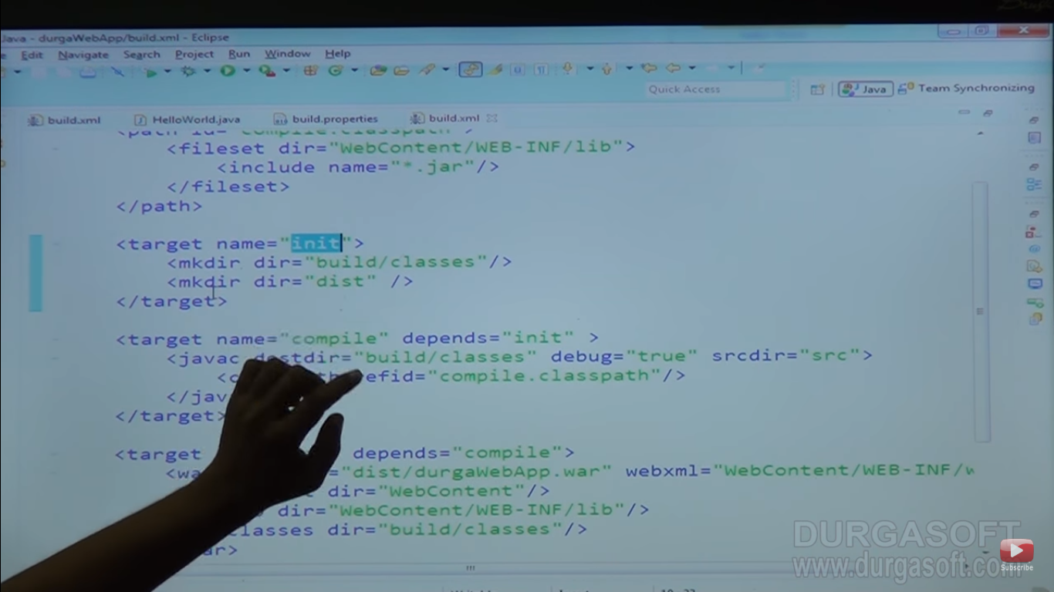

Step 2: compiling will excuite

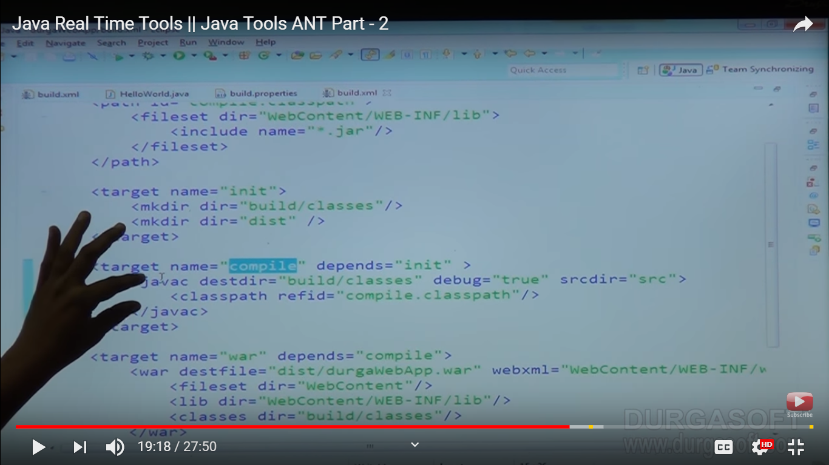

Note : here this spring realated application so we need to give proper class path which is “compile.classpath”

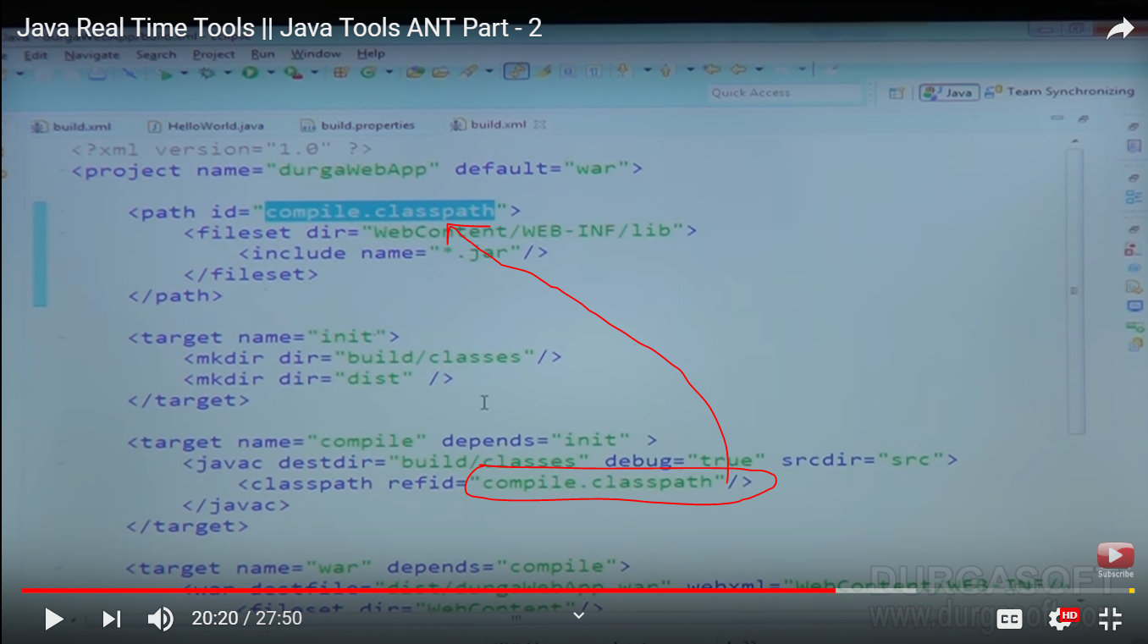

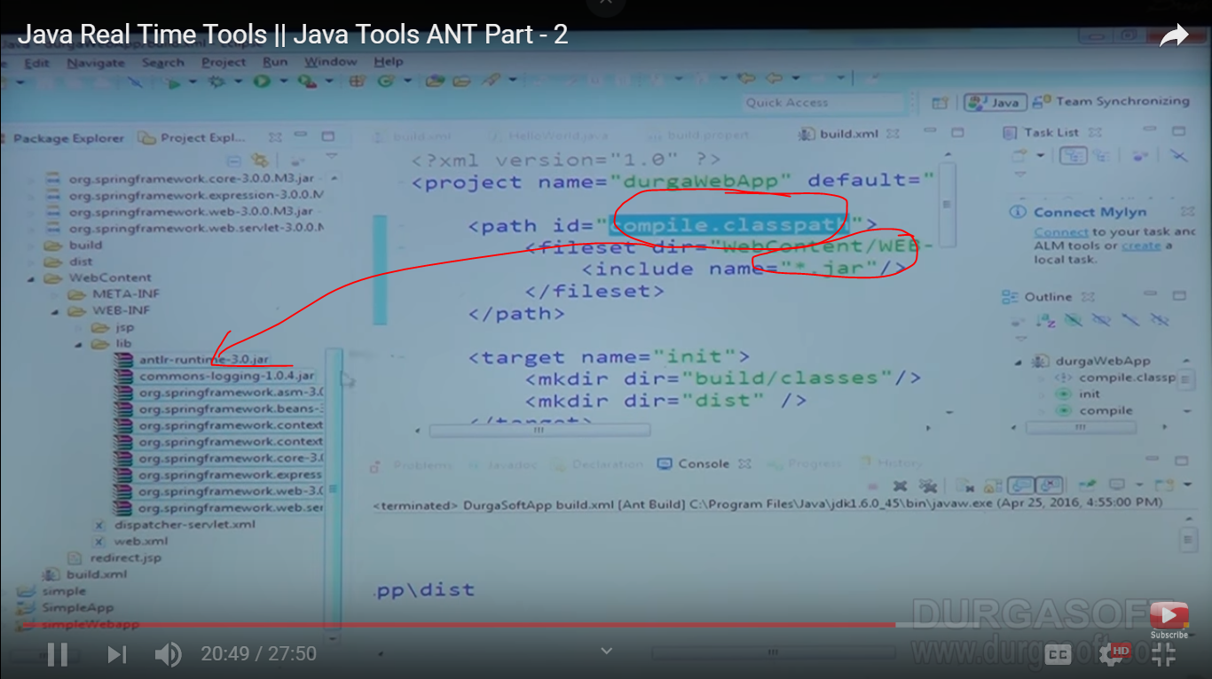

This compile.classpath will tell you that you need dependent jar for running this application so you need to mentioned here

Notes: first take refid and take that .class file then it will compile our class using **javac**

Step 4 : Now war steps

First generate durgawebApp.war file inside dist folder and uses web.xml because its web application other we need to create fileset,lib,class for structure

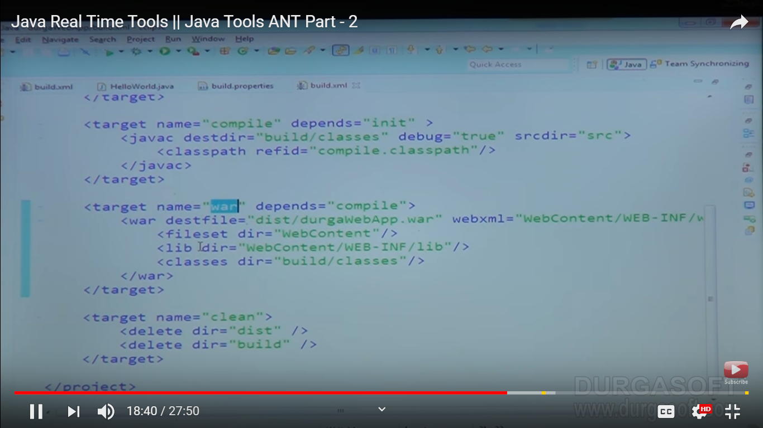

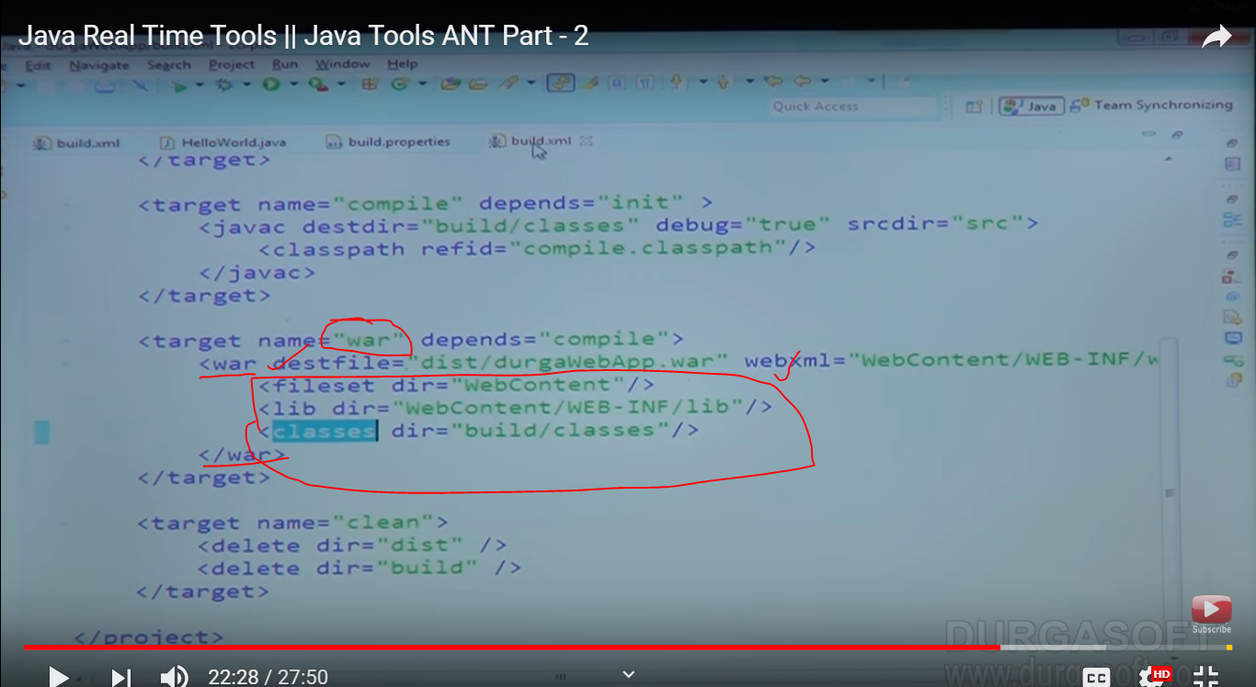

If you open this war you will get in structure manner like this

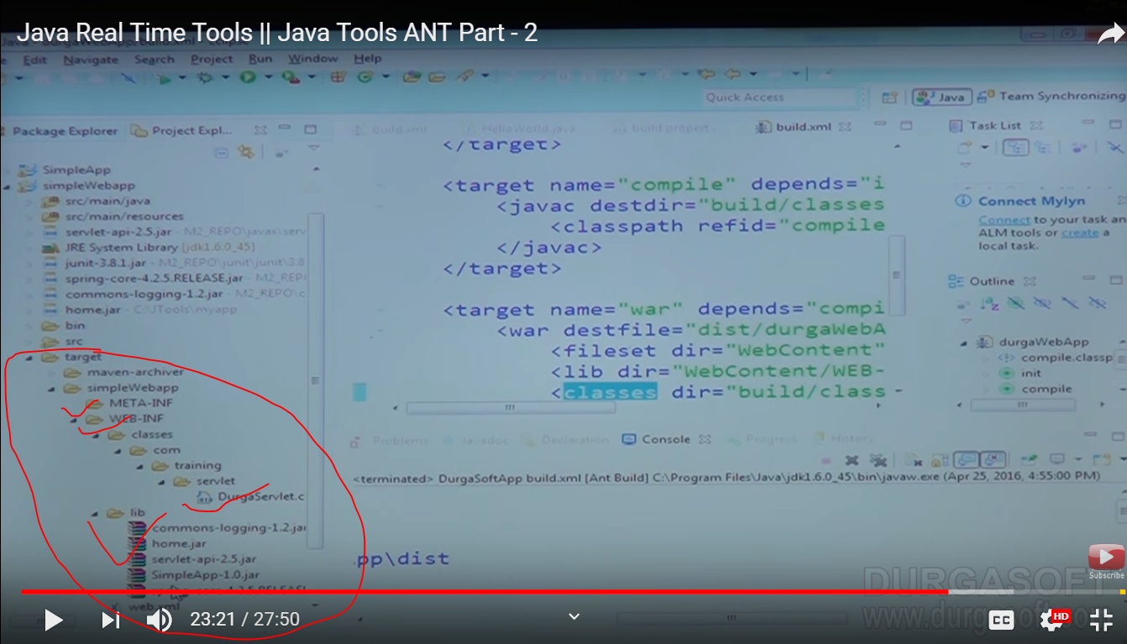

So here lib folder created inside webcontent/web-inf/lib

Class will create build/classes

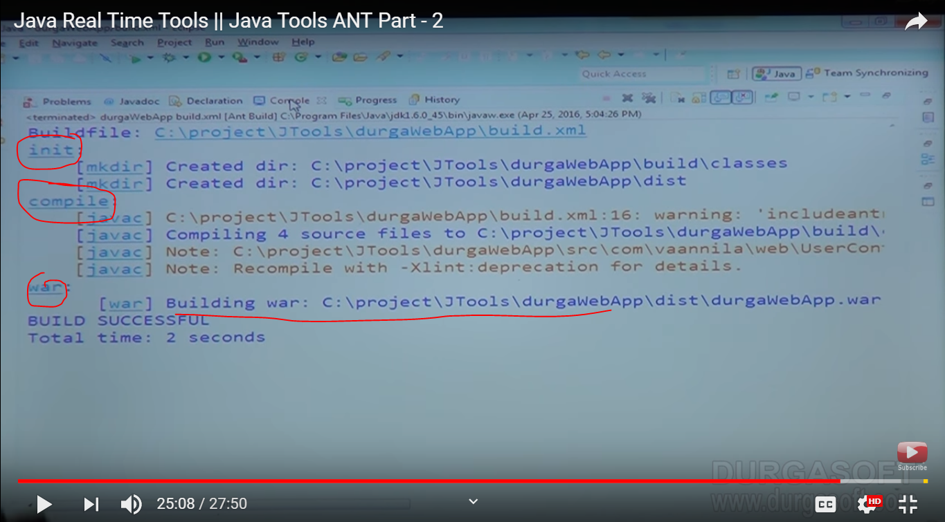

Now war is generated

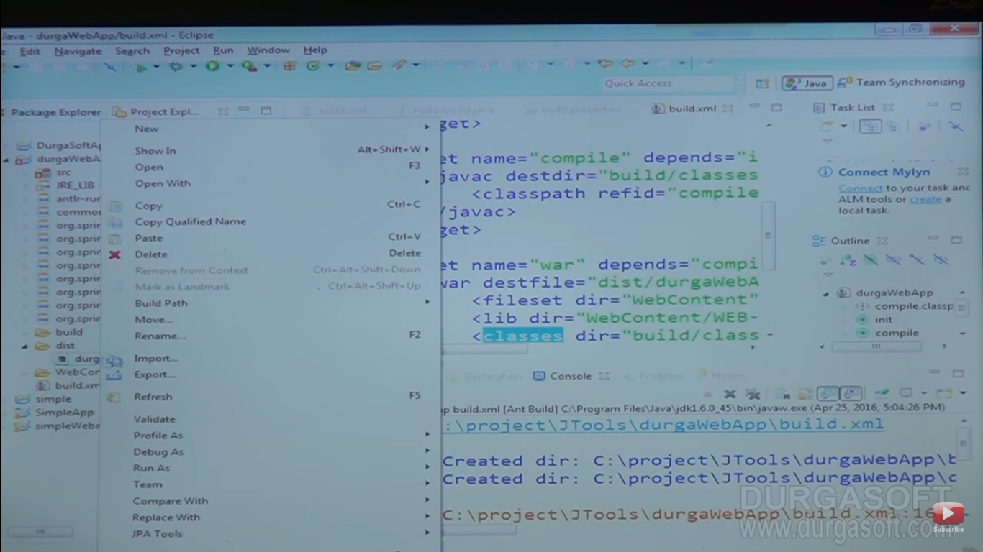

Now copying the war file and placing in the location

Programfile/apachetomacat/webapp

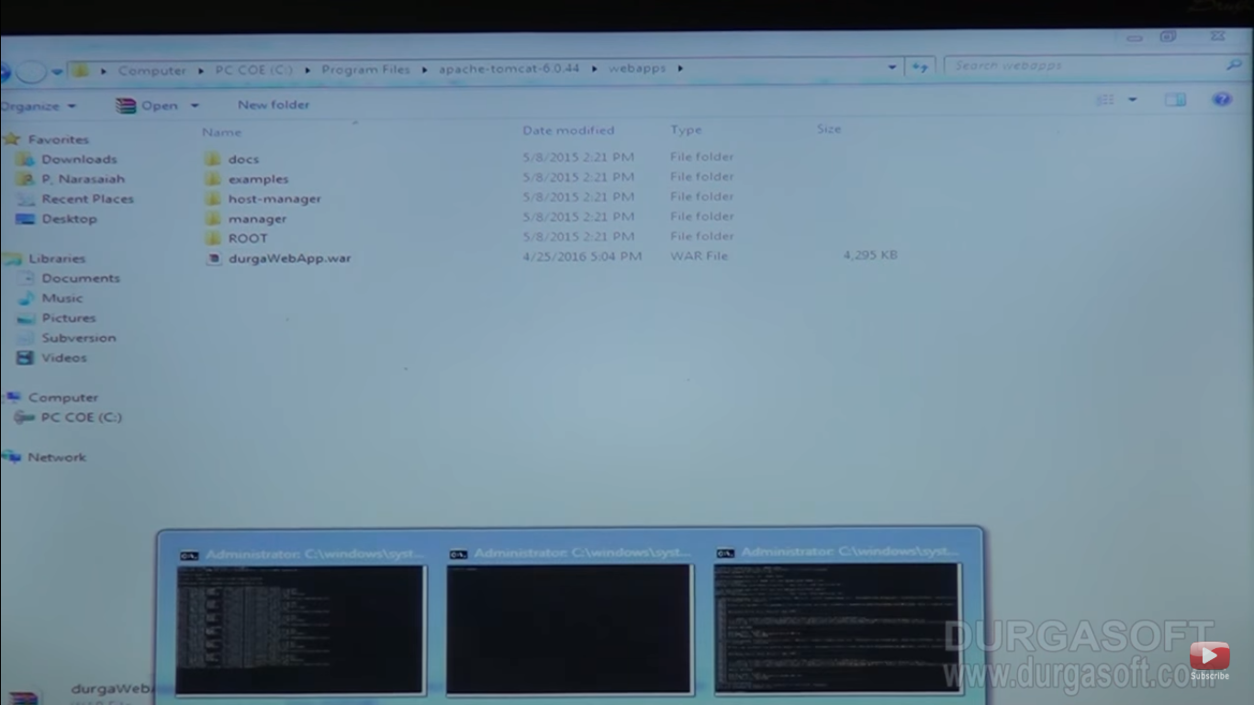

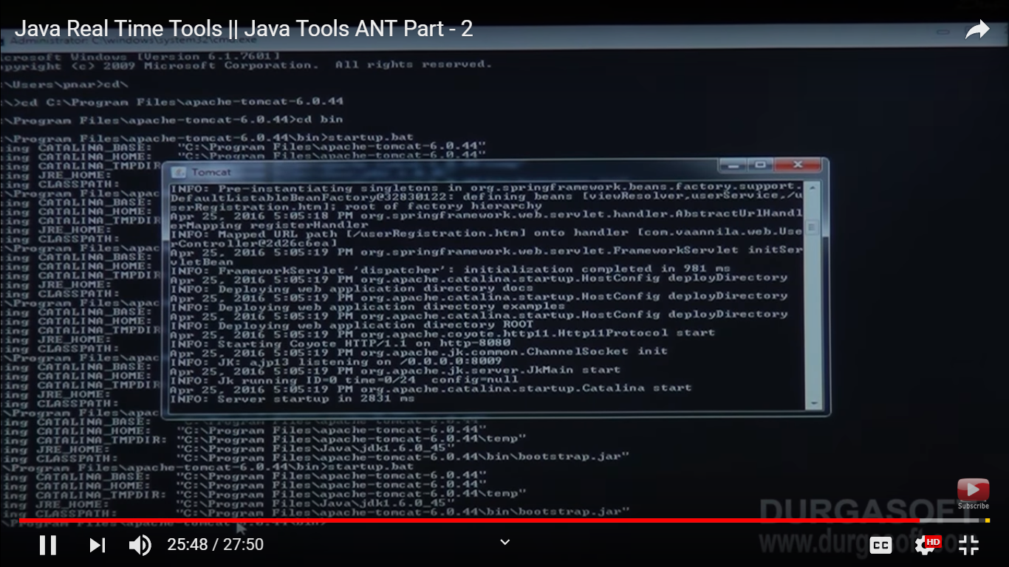

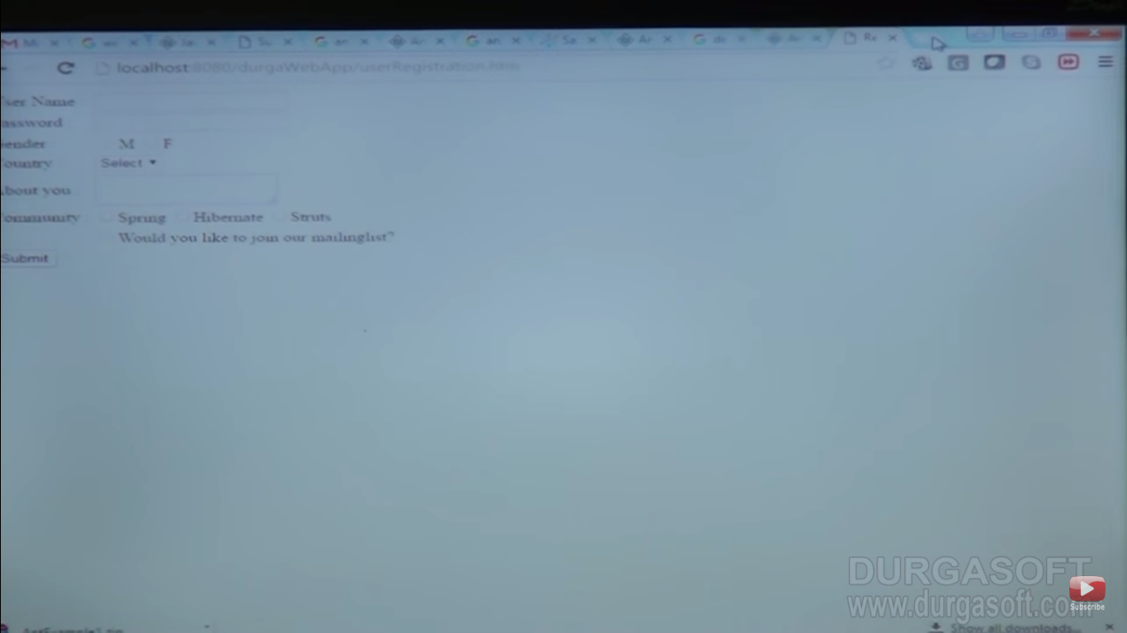

**Jenkins**